
What's Hot at Tribeca Film Festival

by Brandi Andres

April 19, 2011

The annual New York film festival kicks off Wednesday with documentaries featuring Elton John and Carol Channing, and films that zero in on violence in South Africa, miscegenation in the South and AIDS in Zambia. See photos.

Documentaries chronicling the making of Elton John’s album with Leon Russell, the struggles of transsexual tennis ace Renee Richards, and the career of Broadway great Carol Channing, along with a new movie starring Oscar winner Adrien Brody and a British buddy comedy are among the features at the 2011 Tribeca Film Festival, which begins Wednesday, April 20 and runs through May 1. Juries composed of such luminaries as Nora Ephron, Dianne Wiest, Whoopi Goldberg, and Atom Egoyan will award $175,000 in cash and prizes to winners in the annual festival’s six categories: World Narrative, World Documentary, Emerging Narrative, Emerging Documentary, Narrative Short Film, Documentary and Student Short Film. Here’s a look at the lineup:

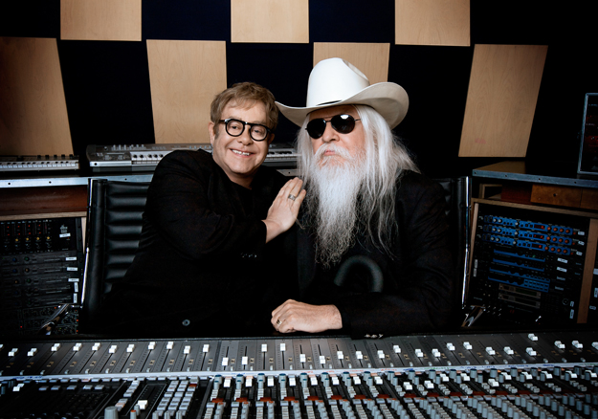
The Union

From Cameron Crowe, the Oscar-winning writer and director of Almost Famous, comes a new documentary The Union, which follows Elton John and his early-career idol, Leon Russell, through the making of their 2010 album of the same name. The feature, which opens the festival, highlights the British superstar as he composes the album—a process never captured on film before. It includes appearances by award-winning producer T-Bone Burnett, Neil Young, Brian Wilson, Stevie Nicks, and Don Was. Russell, who has collaborated with everyone from Willie Nelson to Aretha Franklin to Frank Sinatra, is a rock legend in his own right, with more than 40 albums to his credit. Following the outdoor premiere of the rock doc, John is set to perform live at the World Financial Plaza.

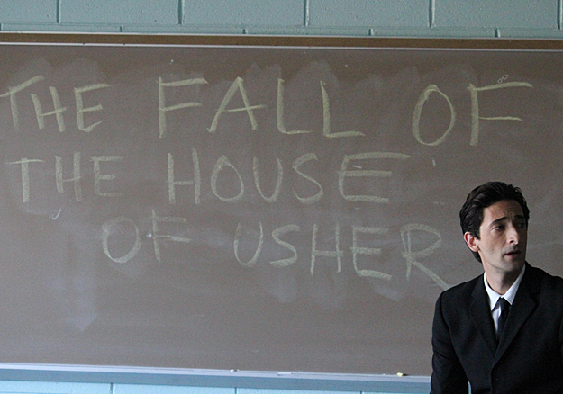
Detachment

Adrien Brody stars in Detachment, playing substitute teacher Henry Barthes, whose narrow world view is altered when he’s assigned a challenging position at a failing public school. Tony Kaye (American History X) directs this moving tale of the American education system. Also starring are Marcia Gay Harden, Christina Hendricks, Lucy Liu, and James Caan, among others.


Renee

In 1976, former ranking men’s amateur tennis player and ophthalmologist Dr. Richard Raskind decided—following sex reassignment surgery—to enter the U.S. Open as Renee Richards. Richards initially was denied entry on the ground that she wasn’t born a woman. But the following year, a court order allowed her to compete. Renee, directed by Emmy winner Eric Drath, examines Richards’ life and trials during those highly publicized years of transformation in the 1970s. The film looks at the challenges she faced fighting for her human rights in the sport, as well as her struggles with her relationships, including with her son.

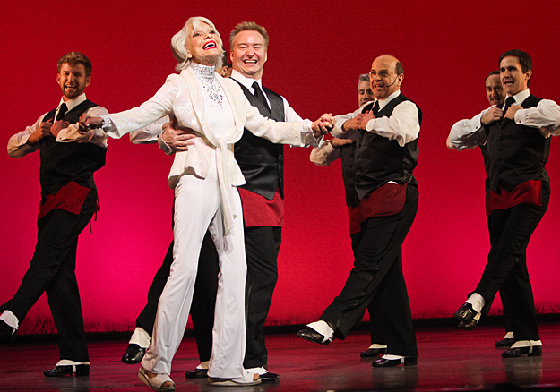
Carol Channing: Larger than Life
Image: Peter James Zielinski

The recipient of three Tony Awards, Broadway legend Carol Channing is known for originating the roles of Dolly Gallagher Levi in Hello Dolly, and Lorelei Lee in Gentlemen Prefer Blondes, which Marilyn Monroe made famous on the big screen. Channing’s expressive personality, brilliant comedic sense, and brightly colored clothes and lipstick have made audiences smile for 70 years. Now, through the documentary Carol Channing: Larger Than Life, audiences can get a glimpse of the 90-year-old actress, singer and comedienne’s thoughts on her experiences and enduring career. The film is directed by Dori Bernstein, whose previous documentaries include Gotta Dance, about the New Jersey Nets’ senior citizen hip-hop dance team and Show Business: The Road to Broadway.

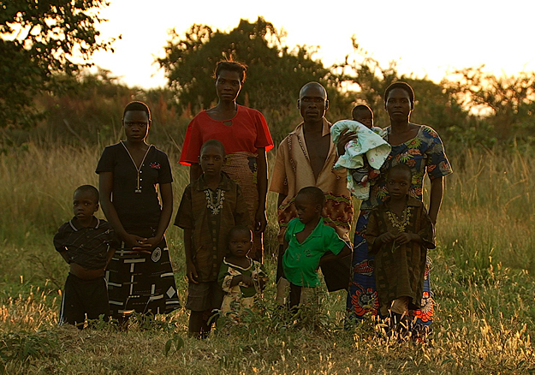
The Carrier
Image: Courtesy of TriBeCa Film Festival

In Zambia, it’s estimated that one in every seven adults is living with HIV, and more than 250 are infected daily. In The Carrier, a 28-year-old pregnant woman, Mutinta, whose husband is a polygamist, learns that she’s HIV positive, and must find a way to keep her unborn baby from contracting the virus. The documentary’s first-time director, Maggie Betts, has spent the past five years as a volunteer and philanthropist, working with various organizations in sub-Saharan Africa. She became especially interested in Prevention of Mother to Child Transmission (PMTCT) programs, drawn by the remarkable women who have been forced to fight for their own lives, and for the lives of their unborn babies.

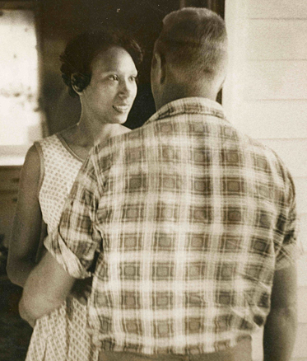
The Loving Story
Image: Grey Villet

This June will mark 44 years since the Supreme Court case, Loving v. Virginia, which resulted in interracial couples being allowed to marry. The Loving Story is a social commentary about Richard Loving, a white man, and his wife Mildred, who is black, who married in Washington, D.C. at a time when the state where they lived, Virginia, had on its books anti-miscegenation laws that prevented interracial couples from marrying. Upon their return home, the couple were arrested. The film’s director, Nancy Buirski, decided to use authentic film footage, photographs and witness narration from the time, to give audiences an honest look at the Jim Crow South, and how opposition to miscegenation is, “arguably, the root of racism.”

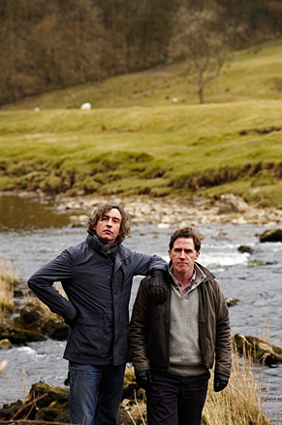
The Trip
Image: Phil Fisk

The Trip is a comedy about two buddies—fictionalized versions of British comic actors Steve Coogan (Percy Jackson & the Olympians) and Rob Brydon—who tour the English countryside, with its charming restaurants and hotels and embark on a journey in search of fame and self realization, after Coogan and his American girlfriend split. Critically acclaimed director, Michael Winterbottom (A Mighty Heart), brings the film, which is an edited version of a six-episode BBC series of the same name, to Tribeca beginning Thursday. It made its debut at the Toronto Film Fest last year.

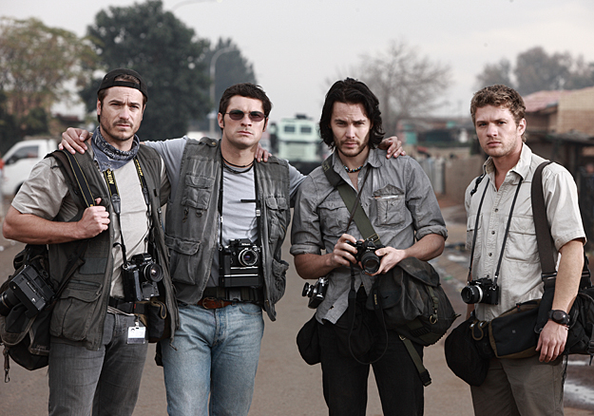
The Bang Bang Club
Image: Marcus Cruz

Ryan Phillippe is in the ensemble cast of The Bang Bang Club, based on a true story about four photojournalists—Greg Marinovich, Joao Silva, Kevin Carter, and Ken Oosterbroek—who from 1990 to 1994 showed the world the horrors they witnessed, and photographed in South Africa, following Nelson Mandela’s release from jail. The group became so known for capturing the violence in the streets of South African townships that they were named “the Bang Bang Club,” by a Johannesburg magazine, Living. Documentarian Steven Silver takes a look inside the often heroic, yet also tragic lives of these four men, based on the photographic book The Bang Bang Club: Snapshots from a Hidden War.

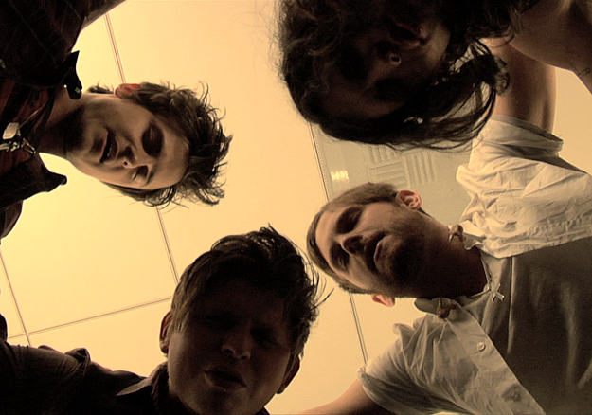
Talihina Sky: The Story of Kings of Leon
Image: Courtesy of TriBeCa Film Festival

While this band might be known internationally for such songs as “Sex on Fire,” and “Use Somebody,” the three brothers and one cousin who make up Kings of Leon were raised to use a more, well…biblical tongue. In the documentary Talihina Sky: The Story of Kings of Leon, audiences will see the real story behind the upbringing of the Followill brothers’—Caleb, Nathan, and Jared—and their transition to secular music. Their father, Leon Followill, a preacher in the United Pentecostal Church, moved the family around the southern Bible Belt, from church to church, to spread the word. The work-in-progress film is anchored in Talihina, Tennessee, and the actions surrounds a family reunion. It is the creation of first-time film director Stephen C. Mitchell, who has worked in the music business for 15 years, and who signed Nathan and Caleb to their first publishing deal.

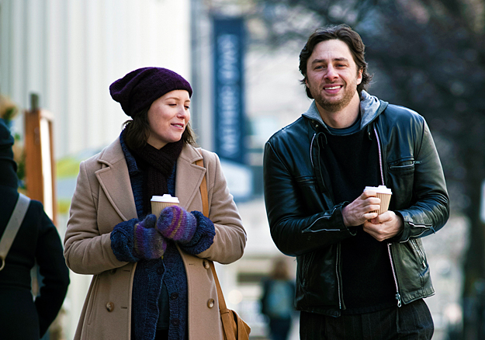
The High Cost of Living
Image: Jan Thijs

In Deborah Chow’s feature-film directorial debut, The High Cost of Living, Zach Braff (Scrubs and Garden State) stars as a dealer of illegal pharmaceutical drugs whose car—and fate—collides with a pregnant woman, Nathalie (Isabelle Blais). Feeling guilty about fleeing the scene of the accident, Braff’s character, Henry, seeks out Nathalie in the hopes that he can make amends. Until he learns she lost the baby. The story’s bittersweet mood, unconventional romance, and emotional highs and lows seem ready for a grand premiere as an official Tribeca selection.

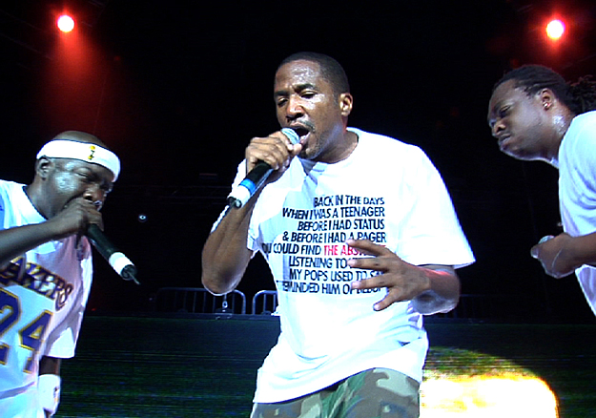
Beats, Rhymes & Life: The Travels of A Tribe Called Quest
Image: Courtesy of TriBeCa Film Festival

In Michael Rappaport’s directorial debut Beats, Rhymes & Life: The Travels of A Tribe Called Quest, which premiered at Sundance this year, audiences once again find themselves taken with the entanglements of the music artists’ world. If you were around in the early ‘90s, and listened to any Top 40 radio station, you’re probably familiar with songs by A Tribe Called Quest, such as “Bonita Applebum” and “I Left My Wallet in El Segundo.” The groups’ jazz-infused hip-hop with social and political themes influenced, and changed the sound of music. The film, which includes commentary from Busta Rhymes, Mary J. Blige, Kanye West, and the Beastie Boys, to name a few, has two showings at Tribeca, beginning Wednesday, April 27. Recently, one of the members of A Tribe Called Quest, Q-Tip urged other rap and hip-hop artists to follow his lead, “Tell your stories,” he said.

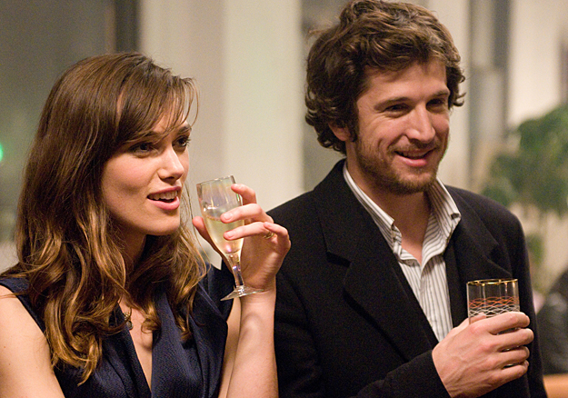
Last Night
Image: JoJo Whilden

This film has already had a number of limited releases around the world, including its debut at Toronto’s film festival, but this Saturday, April 25, Last Night, starring Keira Knightley and Sam Worthington, makes its U.S. premiere at Tribeca. Joanna, seemingly happily married to Sam, feels threatened when she discovers that his upcoming overnight business trip is with a sexy co-worker, Laura (Eva Mendes). And when Joanna runs into an ex-lover whom she still has feelings for she questions her own fidelity. The film, by first-time director Massey Tadjedin (screenwriter of The Jacket), can also be seen in homes across the nation on Video-on-Demand beginning April 20, and will have its limited release in theaters starting May 6.

