Montreal Bagel Throwdown: Fairmount vs. St-Viateur
Posted by Amie / July 12, 2010
11 Comments ShareThis
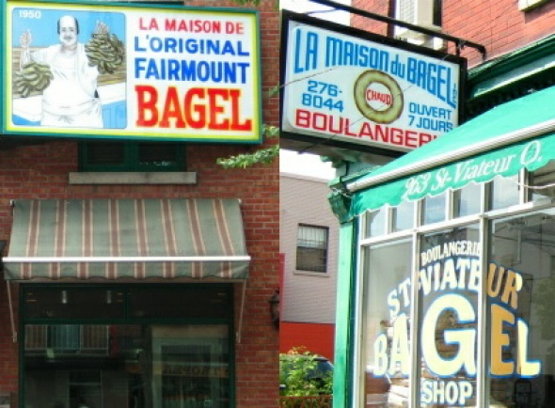THE CRITERIA: Freshness, Sweetness, Texture, Crust, Size, Overall Bagel Experience
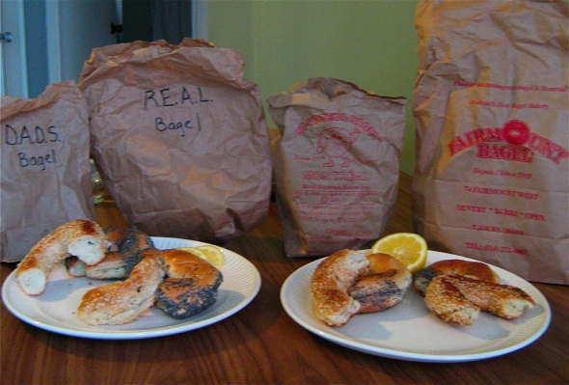The Methodology: To objectively compare Montreal's finest bagel establishments I drove from bagel shop to bagel shop, having a few bites of the fresh bagels and taking notes just after purchasing. At the end of the trip I did a direct comparison between all the bagels purchased. The following day there was another comparison of all the bagels purchased (the photo above with lemon as a palate-cleanser. Bagels are serious business). While this was mainly a comparison of Fairmount and St-Viateur bagels, to cover all the bagel ground in the city, I also compared D.A.D.'s Bagels and R.E.A.L Bagel. Sesame seed and Poppy seed bagels were purchased at each bagel shop, along with unique or specialty bagels at certain establishments, but for the the purposes of this study, only the sesame and poppy seed bagels were used to determine the winners in each category.
The 5 bagel shops tested were (in order of purchase):
D.A.D.'s Bagel (5732 Sherbrooke West), R.E.A.L. Bagel (6160 chemin de la Cote-Saint-Luc), St-Viateur Bagel (263 St-Viateur West), St-Viateur Bake Shop (158 St-Viateur West), and Fairmount Bagel (74 Fairmount West)
A Brief History: Fairmount is the original Montreal bagel shop, but long before there were "Fairmount bagels", there were Chaim Seligman and Isadore Shlafman. In 1919 Shlafman started selling bagels in an alley off St-Laurent, but according to Jewish historian, Joe King, Seligman was the original bagel guy, selling his strings of bagels from the back of a horse-drawn buggy up and down St-Laurent. Seligman then went into business with Jack Shlafman (of the Fairmount lineage) and a new-to-the-scene bagel-maker, Myer Lewkowicz. That didn't last long. One big falling-out later, the Shlafmans moved into the current Fairmount Bagel location in 1949 and Seligman and Lewkowicz got it together to open St-Viateur in 1957. The names and the traditions were born, and they were connected. In 1963 Joe Morena took over St-Viateur. Flash forward to the 1990's and Montreal-style bagel offspring R.E.A.L. Bagel and D.A.D.'s Bagel (I don't think there's any real blood connection. Definitely not with D.A.D.'s Bagel, whose owners are Punjabi) opened, using the same bagel-making method.
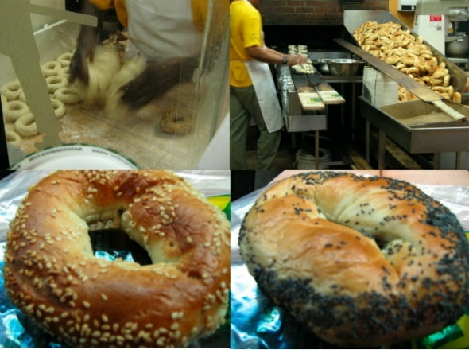The Bagel: There are only 8 ingredients in a Montreal-style bagel. These are flour, sugar, yeast, oil, honey, egg, malt, and Montreal water. The quantities and quality of the ingredients are what make the difference. They're what make your bagel slightly more of less stale the next day (more or less egg probably), determine the fluffiness of the dough (type and quantity of flour based on amount of gluten, amount of oil, amount of egg, and use of honey in the dough itself which will make it dryer) and the all-important sweetness (whether honey is used in addition to sugar in the kneaded dough, and the flavour of the malt). The standard these days is to use an unbleached white flour, though each shop's brand of choice may differ and may have changed over the years.
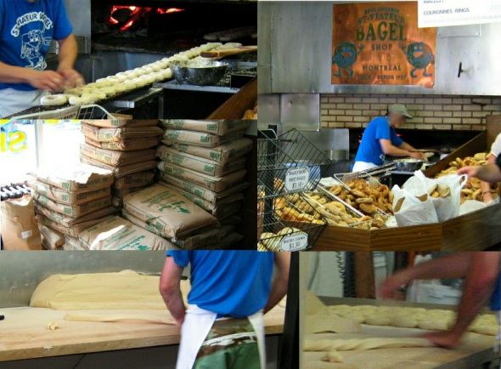In all of the above establishments similar bagel-making equipment and methods are used. The ingredients are mixed and kneaded in a giant dough-making machine, then left to rise for about 45 minutes. The huge block of dough is then sliced into bagel-width strips and hand-rolled and twisted, one at a time, into bagel shapes. The bagels get thrown into a big vat of simmering honey-water that looks a bit like a deep-fryer, for about 5 minutes. They then get fished out, dragged through sesame or poppy seeds, and placed in lines on long, thin, planks of wood, and baked in an open wood-fired oven for 10 minutes.
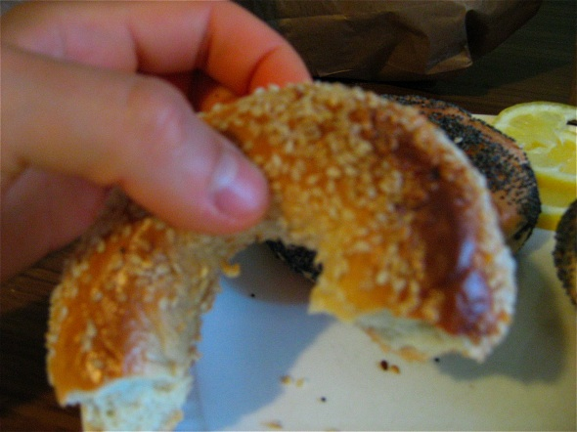What happens in the oven is very important. The bagels start close to the heat for about 5 minutes, then are slowly moved away from the flames to finish on the cooler side of the oven. The inconsistency and unpredictability of the flames are what give the bagels the darker-in-some-spots look. They're also what turn the sesame seeds into a real topping, so you feel like you're eating a bagel slathered with toasted, delicious nuts when it comes out fresh, instead of a bagel covered in something generically chewy. The poppy seeds get toasted too, but the effect isn't quite the same. So for sesame bagels you don't really need anything on top of them, but smoked salmon or cream cheese, or both, work really well. Since there's no salt in the bagels themselves, adding smoked salmon doesn't feel like you're eating a week's worth of sodium.
THE RESULTS
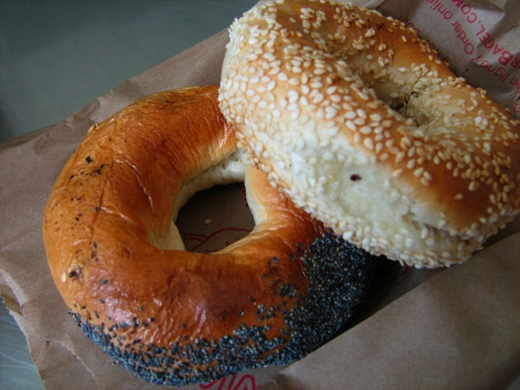Freshness: St-Viateur
It has to be fresh! The most important revelation of this taste-test was that all of these bagels were good as long as they were hot out of the oven. Be warned, bagel-eaters, that while all these places use wood-burning ovens, Fairmount actually uses an electric oven for its wholesale operation. So if you buy outside of the Fairmount bagel shop you're not getting the real deal.
Sesame was the most popular flavour at all the bagel shops, and it was the only one that was ever really fresh. Not that it's a better flavour, just that more people buy it, so if you prefer poppy seed you have your work cut out for you to either find a consistent way of getting your bagels while they're hot (a bagel bell?) or make poppy seed bagels more popular so they're baked more often. St-Viateur doesn't even make a new batch of poppy seed until the last ones are almost gone, but their sesame bagel was my best bagel of the day. R.E.A.L. Bagel and Fairmount were both working on batches of sesame at the time of purchase so if you want more fresh poppy seed bagels in Montreal you'll need to start an uprising to turn the market trend in your flavour favour.
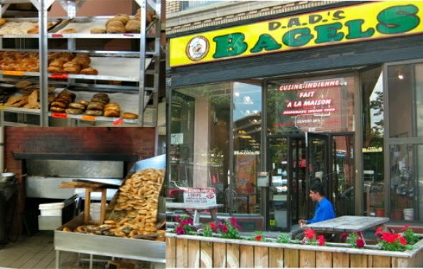D.A.D's bagel only bakes in the morning and at night, so if you come during the day there's absolutely no way your bagel will be really fresh. The sesame at R.E.A.L. Bagel was warm, but not hot. Not good enough. At Fairmount, like St-Viateur, only the sesame was fresh. Forget about buying at the grocery store; you need to go to the source. Often in the bake shops themselves they'll even sell you the cooler bagels because that's what makes financial sense - get rid of the old product to bring in new - but that's not what you want. It has to be hot.
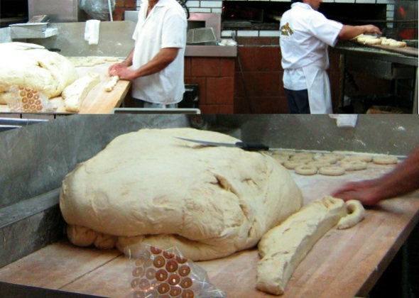Sweetness: Fairmount
D.A.D.'s was too sweet, R.E.A.L. Bagel was bland, and St-Viateur was just neutral. Normally I would say the sugar wasn't really necessary, just addictive, but you're dealing with multiple kinds of sweetness from the sugar, honey and malt. The most flavour comes from the malt, and so Fairmount's higher malt and sweetness created more overall flavour for the bagel. I'll be honest, I could taste the difference in sweetness a lot more the day after, once the bagels had cooled down, but when the bagels were fresh it was a tough comparison. I kept trying the St-Viateur and Fairmount the day after to make sure I wasn't wrong about the sweetness, but Fairmount was just better.
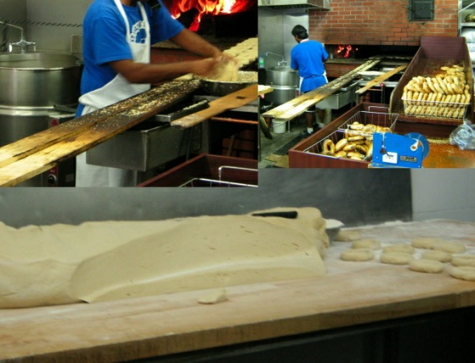Best Texture: St-Viateur
The texture was so smooth and soft without being doughy, but ONLY when it was fresh. Fairmount was a bit fluffier, but I only preferred this the day after, when St-Viateur became very crunchy and hard but Fairmount stayed relatively chewy. I'm certainly not going to buy a bagel for its 'day-after' attributes. R.E.A.L. Bagel and D.A.D's just couldn't compete in this category because the texture was automatically not as good when the bagels weren't hot. It shouldn't feel like work to chew a Montreal bagel.
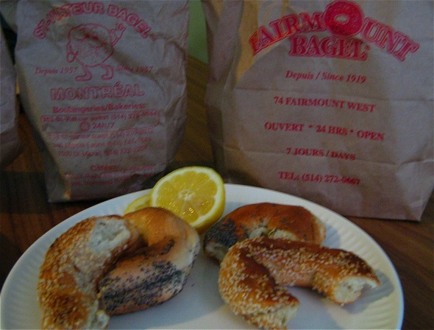Best Crust: St-Viateur and Fairmount Sesame Bagels
There's really only a good crust when the bagels are hot. You can re-toast, which is fine, but your toaster or toaster-oven is not a wood-burning bagel oven. Both St-Viateur and Fairmount sesame bagels (because they were the only really fresh ones) had a crispy, nutty outside to contrast the smooth, luscious inside.
Size: St-Viateur
St-Viateur, both the shop and wholesale bakery, were the only place to consistently and correctly size all their bagels, from sesame and poppy seed to all-dressed and cinnamon raisin. Montreal bagels are not big and fluffy. This is not a roll. This is not a pillow of flour-y fluff. This is smaller, finer affair.
Fairmount had well-sized poppy seed and sesame but the others expanded from there. Honestly, I liked the blueberry bagel and cinnamon raisin a lot, but not as Montreal-style bagels. A purist would reject them outright. Pumpernickel had a pretty good flavour, but muesli was just weird. Maybe if you live on muesli but are dying for a bagel you'll appreciate it more? R.E.A.L. bagel seemed huge by comparison, though their sourdough (made without eggs and sugar) was actually really good and deliciously tangy from a good sourdough culture, but the size and flavour made it more like bread than a bagel. Perfect for a bagel sandwich, but not really a Montreal-style bagel at all. The R.E.A.L. Bagel poppy seed version was more appropriately 'Montreal', so the bagel-roller was just a little inconsistent. D.A.D.'s were a good size but just by looking at the batch made that morning you could tell that the consistency just wasn't the same as St-Viateur.
Overall Bagel Experience: St-Viateur
I'll be honest, all these bagels are very similar. What can set a bagel apart is the experience that goes along with its purchase. St-Viateur (263 St-Viateur West) was hands-down the friendliest place I went into. Yes, there was a steady stream of patrons, but never did I feel rushed out of there. Actually it was kind of hard to leave because I started asking questions like I always do and ended up in a long conversation with the man at the cash. He'd started coming in as a patron Friday night/morning (it is 24 hours), buying some bagels, and hanging out for a few hours. It got to the point where the owner said that if he was going to come in every week and hang out, he might as well work while he was there.
And he's been working there ever since. He chats with customers, but he doesn't waste time. Now this is just one worker, and on a different day at a different time I could have had a different experience, but St-Viateur is cultivating that family-friendly appearance that makes you feel welcome and invited. This was emphasized by the total contrast of walking into Fairmount and feeling crowded and unwelcome. The ordering space isn't any smaller than St-Viateur, but it feels more closed off from the bagel ovens, and getting to the cash feels like a pressure situation. Go, go, go! Pay! Get out! I started asking questions, which was not appreciated. Pictures were frowned upon. The cashiers couldn't tell me exactly how the different bagels were made or even what was in them. They were just employees, not people who cared about and knew about the bagels.
At R.E.A.L. Bagel I had another good experience, and the guy at the cash was a little tickled that I had such an interest in the bagels. I mean, it's not St-Viateur or Fairmount, so tourists don't head out to that bagel shop too often to discuss the finer points of bagel-making. D.A.D.'s was also wonderful. The friendly man explained that while the shop is both a place for 24 Hour bagels and Indian food, it started out as just bagels. THAT is what his family figured would sell in Montreal at the time. they were right, but the tandoori chicken looked amazing. Convenience store food this is not. If you like Indian snack food, like bhajis, get them fresh. The home-made samosas stay at their best a bit longer, but not all night. So this place has more than bagels going for it.
Walking into all these places it was incredible to see how far the Montreal bagel has come. Joe Morena, the owner of St-Viateur after Lewkowicz, summed it up in 1988 when he said,
"What I really am is living proof that you don't have to be Jewish to make or love bagels."
Thanks, Joe. Montreal can be proud to call you its own. The diverse bagel establishments in this city all do a great job, and as long as the bagels are fresh, you won't be disappointed at any one of them.
But...
OVERALL WINNER: St-Viateur
While I actually prefer the taste of Fairmount, loyalty is what the Montreal bagel is really all about, and I want to give my loyalty to the St-Viateur company. They seem to care more about the bagels, and their bagel-making and selling philosophy. When you walk in to the shop you feel like you're walking into Montreal history, not a commercial operation. While I wouldn't turn down a bagel from D.A.D.'s if I was in NDG late one night, and I wouldn't turn down a trip to R.E.A.L. bagel if I was out by cote-st-luc, on the Queen Mary (4940 chemin Queen-Mary), or near the original in Dollard-des-Ormeaux (3702 boulevard Saint-Jean, Dollard-des-Ormeaux), I am slowly placing myself in a St-Viateur bagel-loyalty group.
Hopefully I'll have lots more Fairmount bagels before I turn into an old person in a rockin' chair telling stories to anyone who'll listen that start with, "Back in my day, when Morena was running St-Viateur, long after the original Shlafman had passed on his Fairmount legacy, people swore by the best Montreal bagel..."
To listen to a radio program describing this Bagel-testing adventure, follow the link to the CKUT archived audio stream of the Friday Morning After Show from July 9th, 2010. The bagel discussion can be found half-way through the stream.

