The Quest for Gleaming, Smooth Skin
by Amber Katz
With summer rapidly approaching, you need not only to prepare your body for its debut on the beach, but your skin as well. Shed the dry and uneven, stuck-inside-under-fluorescent-lighting skin you’ve been harboring for the past eight months and choose your weapon to reveal a glowing Halle Berry-esque epidermis.
Body scrubs have traditionally been used in Eastern spas for deep cleansing and detoxifying the skin, leaving it extremely clean and unclogged. I know a girl loves options and the three methods I explore (ranging from low to high-end) are sure to result in a positive bikini revealing experience.
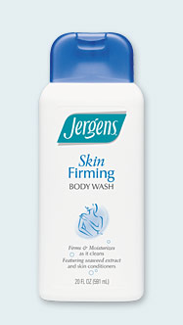
Weapon One: Jergens Skin Firming Body Wash/ Body Shop Exfoliating Skin Towel
Just as hair becomes immune to shampoo, , using the same exfoliating agents steadily over a period of several months becomes inefficient. The best way to avoid this: change the manner in which you exfoliate, i.e., a body scrub and washcloth combo vs. a shower gel and scrubby towel combo. The latter yields the best rosy, polished skin result. Some might call it irritation, I call it the desired effect.
Jergens Skin Firming Body Wash is a white, pearlized gel that touts less cellulite and firmer skin. The wash comes in a no-frills, white plastic 20 oz bottle at an extremely reasonable $5.99. I’d best describe Jergen’s Skin Firming Body Wash’s scent as fresh, yet soapy. It’s also non-oily, so you will not risk injury in the bathtub. It rinses clean and lathers just enough to make you feel you are pro-active in your quest for clean, yet luminescent skin.
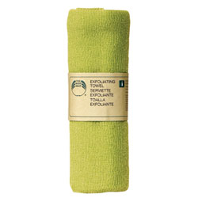The Body Shop’s Exfoliating Skin Towels are conveniently sold in packs of two ($7.50). They are rolled up together in a tube that is so compact you can stock up even the smallest New York City linen closet. But don’t let their bright feminine array of color choices fool you, the towel’s texture is not for the weak;it is a coarse nylon exfoliant. It gets down to business in a WWE kind of way. Do not attempt if you have sensitive skin.
Since there are no granules and no oils, this product is the cleanest of all three products reviewed. Be careful that you thoroughly rinse your towel and hang in the shower so that it can dry completely between uses to eliminate bacteria growth.
The result is skin that is much smoother, softer, flake-free, and luminous as all get-out. I’d also say that my butt and thighs seem a bit firmer and tighter. There is no cure for cellulite, but I’d say the appearance of mine (alas, I have some) is much reduced.
Repurchase? Definitely. The towels are a permanent fixture in my bathroom; I’ve gone through about 2 a year for the past 7 years or so. And since I use Jergens Skin Firming Body Wash only a couple times a month, it lasts me quite a long time.
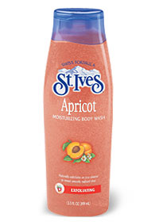Weapon Two: St. Ives Apricot Exfoliating Body Wash
St. Ives Apricot Exfoliating Body Wash is more of a gel that has exfoliation properties than a scrub. It’s peach-colored and infused with tiny granules. However, there aren’t very many granules—certainly not enough to produce the exfoliated effect as touted on the package - I prefer a more atomic scrub. It lathers, but not too much. Conceptually, lots of lather seems to contradict the exfoliation effect and apparently, St Ives agrees.
The scent is reminiscent of Peach Snapple, but in a good way. I’m not usually a fan of food-scented products, but there’s something homey about the apricot smell of St. Ives. I’ve been a fan of their medicated apricot facial scrub since adolescence.
The wash is packaged conveniently in a bottle with a flip-cap so there is no risk of accumulating germs. Simply flip and squeeze. It’s thick enough that not much product is lost if you use a washcloth or towel. I contemplate using it with a scrub towel. When I do however, the few scrubbing granules get stuck in the towel and do not seem to operate as an independent exfoliant at all. I wouldn’t recommend applying it with your hands and it’s best to add a bit of water and smooth on wet skin, working on one area at a time. I’d use about a half-dollar amount for arms and torso area, and the same amount for legs.
The price is very nice, about $4.50 for a 13.5 oz bottle, and it’s sold at any drugstore. However, the thrifty price is due to its no-frills ingredients. Yes, it does include apricot (extract), but there are no essential oils or especially luxuriant ingredients. After toweling off, I did not notice much improvement in the texture of my skin when used with a washcloth alone. Skin was not all that much smoother, nor very glowy. I felt I still retained my top layer of skin which I had intended to slough off. Skin was flake-free, yet matte.
My tub however, was left refreshingly clean. The wash rinsed clean off my body with minimal residue around my drain. Because it isn’t oily, the tub’s floor dried perfectly with no mess.
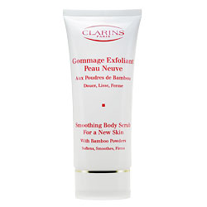Weapon Three: Clarins Smoothing Body Scrub for New Skin
This light, seashell pink scrub has a fine, granular texture almost like cake batter that doesn’t have enough water added. The tiny granules are thick as paste when squeezed out of its stand up bottle that features my favorite, a flip-top lid. The bottle is beautiful Clarins-style white with scarlet lettering and gold accents. As I made room for it in the sparse real estate of my tub’s surface, I noted that the average product value of my bathroom had climbed significantly.
First, it’s so non-oily that I’d use it in my face as well in a pinch. Say if I were on an exotic vacation and needed to prep my skin for tanning and left my usual facial scrub (Estee Lauder So Polished Exfoliating Facial Scrub) at home. The benefit of oily scrubs is that you don’t have to use moisturizer after showering. But I am wary of anything that leaves a film so thick that using lotion becomes obsolete. It may be inefficient, but I would rather not save a step. The Clarins scrub removes dry skin so well on its own that I wouldn’t recommend pairing it with anything but a washcloth. The small scrubbies would get lost in a sponge and the Body Shop towel would be far too much of an abrasive combination.
The result was noticeably smoother, glowing skin. I felt less jagged and flakey for sure. I had a smooth canvas to apply self-tanner, in which I all but marinate on a weekly basis. Skin was a tiny bit rosy, but not irritatingly so. I would definitely repurchase and would buy two if I had a gift certificate to Sephora.
Here’s the bad news: it’s not cheap ladies—at $33.00 a pop, you may want to hide this one from weekend guests. It’s that good. It’s a bit indulgent, but I believe you get what you pay for. Only a quarter sized squeeze is necessary for arms and torso and another for legs. The bottle holds 6.9 oz so it will last a fairly long time. The thick paste-like texture means you’ll spill less in the process as well.
It’s not absolutely necessary to pay a lot of money in order to successfully scrub away dry skin. I would attest that the Jergens/Skin Towel combo and the Clarins scrub produce similar results though the difference in cost is quite substantial. But no matter which option you choose, remember that skin should not be exfoliated more than twice a week. Every day use can aggravate and damage the skin. You will achieve exfoliation just by applying a scrub, the ingredients themselves do most of the work. Follow with a liberal application of body lotion and tell dry, dull skin to prepare for combat.

