From www.Tennisserver.com newsletter
August 8, 2006

Newsletter Special: Tale of Two Matches at Legg Mason Tennis Classic in Washington, DC
By Joseph E. Hight, with photographs by Pablo Sanfrancisco
Very often the hardest fought and most competitive matches on the ATP tour take place on the side courts. So it was on a hot, very hot, Tuesday evening at the 2006 Legg Mason Tennis Classic in Washington.
On a side court during second round action, Thai sensation Paradorn Srichaphan faced the tall, hard serving lefthander from Denmark, Kenneth Carlsen.
I had observed Srichaphan's workout the day before. At 10:30 am, Paradorn Srichaphan was shirtless, running laps around the William H.G. Fitzgerald tennis center stadium, fitness guru Walt Landers leading the way. After the laps, Srichaphan and Landers played catch with a heavy medicine ball.
After running and tossing the medicine ball, Srichaphan started hitting on a nearby side court with Danai Udomchoke, his doubles partner for the tournament. After the hit, Landers took over and worked Srichaphan with some rapid fire volley drills. Srichaphan's workout lasted all morning.
I thought, "Maybe Srichaphan doesn't have a match until Wednesday, giving him a day to recover."
But on Tuesday at 7 pm, Srichaphan is on the side court right next to the one where he looked to have burned himself out the day before in the 100 degree heat. He is battling Kenneth Carlsen. And it is still close to 100 degrees.
I was curious to see if Srichaphan's extensive workout the day before would take its toll? Would he tire, have nothing left in the Washington heat and humidity?
I was able to observe the contest up close with only the chain link fence and some black netting separating me from the baseline player at one end of the court. I was within yards of the baseline; only feet from where I would be trying to return serve if I were playing.
I could see the spin on Srichaphan's ball, making it a crazy spinning, whizzing yellow sphere tied to the court by the differential air pressures above and below the ball created by the fierce spin. Carlsen countered this spin on his backhand side by using slice, imparting a wicked underspin to send the ball back deep. But if he didn't time it just right the ball would spin off his racquet and out of control. And if he didn't get it back deep, Srichaphan was most likely to hit either a winner on the next shot, or an approach shot followed by a volley winner.
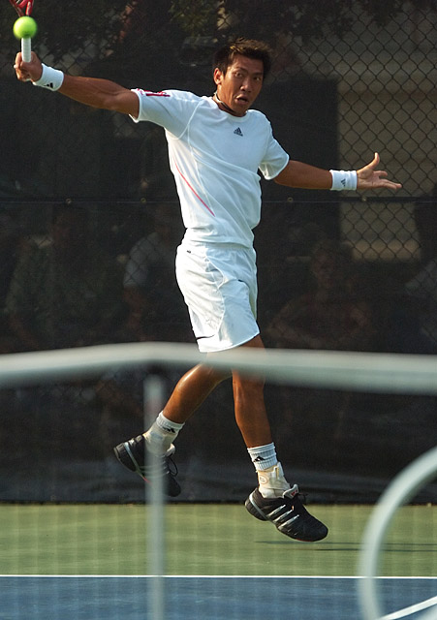
Paradorn Srichaphan playing Carlsen at Legg Mason Classic
Srichaphan jumped out to an early lead, holding serve and breaking Carlsen in the second game. But Carlsen held his serve the next two times and broke back in the seventh game, bringing the score to 3-4. Then each held serve to bring it to 4-4. Srichaphan held serve, and then broke Carlsen in the 10th game to win the set, 6-4.
When play resumed, the concentration and determination on each player's face jumped up a notch. On each point won, Carlsen would do a little clenched fist pump, very close to his chest so that it was almost unnoticeable. Each point won by Srichaphan was greeted with cheers and feet stomping by the sizable Thai contingent of fans looking on.
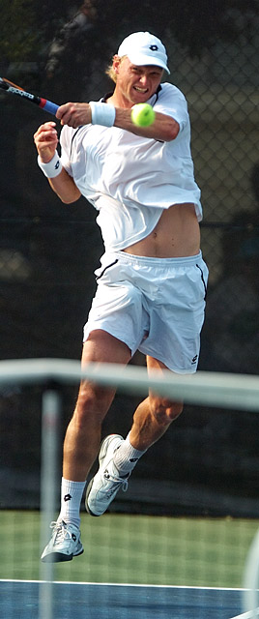
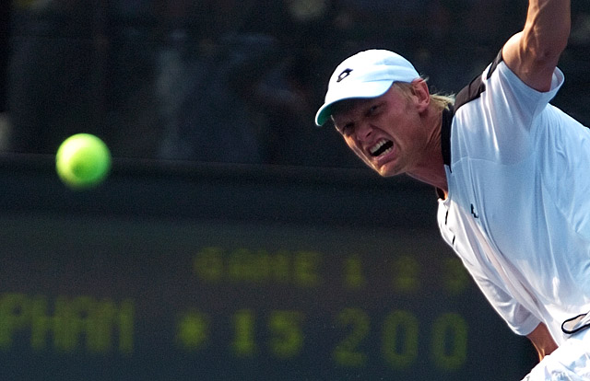
Kenneth Carlsen playing Paradorn Srichaphan at Legg Mason Classic
In the second set, neither player was about to give in. Each gave everything they had to return serves that appeared to be unreturnable. There were no service breaks, and the set went to a tie break. The tie break got to 6-4 for Srichaphan, giving him match point. Carlsen dug in, got it to 5-6, 6-6, 7-6, then won at 8-6.
In the third set, Srichaphan was broken in the second game, after Carlsen had held serve. That was the end. Carlsen won the third set, 6-3, and the match 4-6, 7-6, 6-3.
By this time it was 8:30 pm and Andre Agassi was about ready to start his match on Center Court against the qualifier, Andrea Stoppini of Trento, Italy. Stoppini, ranked # 246 had never won an ATP match since turning pro in 1998 before defeating Paul Goldstein the night before. Agassi couldn't have asked for a better set up for his return and last appearance in Washington where he is a five time champion before he calls it quits at the U.S. Open in September.
But something was different this time. In prior years when I had visited the tournament early in the week, I would see Agassi, shirt off, practicing on a side court, or even on center court in the stadium. This year, Agassi was a surprise late entrant. I didn't see him on the practice courts.
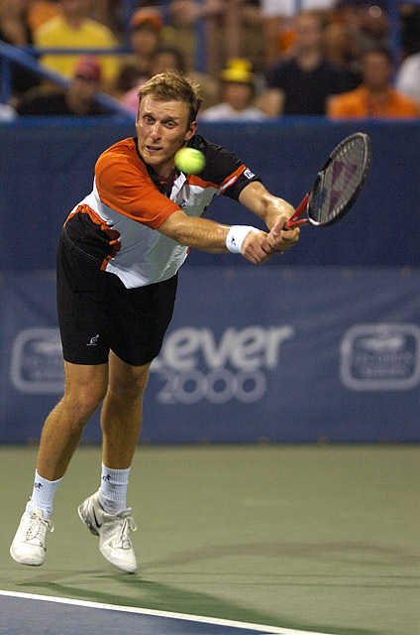
In 8 years on the circuit, 246th-ranked Andrea Stoppini
had never won an ATP match before qualifying for the Legg Mason
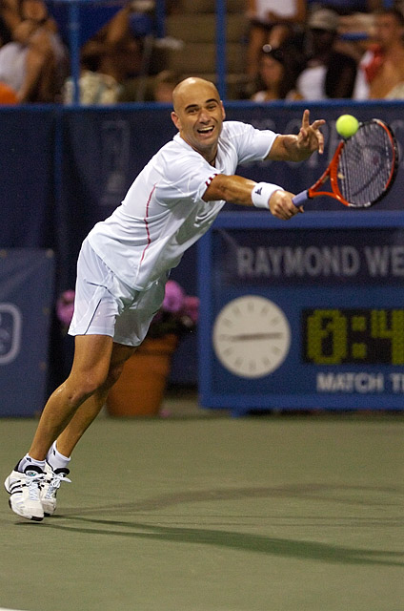
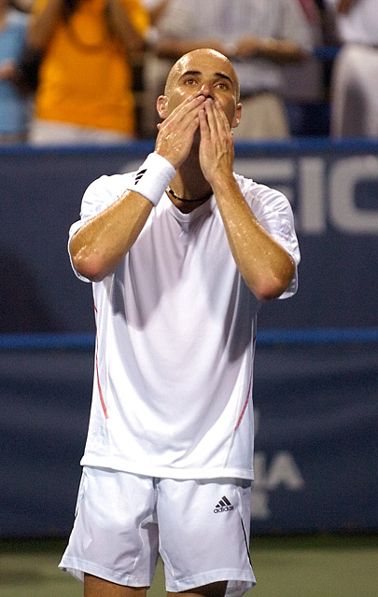
Andre Agassi Made His Farewell Appearance at the Legg Mason Classic
The match lasted for two 30 minute sets. Some serves whizzed by the "best service returner of all time" without an attempt at them. Agassi hit balls long and he hit balls wide. He got only 45 percent of his first serves in, He committed 24 unforced errors to 17 winners.
In his post match session with reporters, Agassi said in response to a question, "It's all a bit surreal. I'm out there trying to do a job, and I feel like I want to have dinner with everybody. It's an odd feeling."
The last report I got was that Agassi was on a plane heading back to Las Vegas.
Joseph E. Hight is a freelance writer in Springfield, Virginia. He writes frequently for the Chronicle Newspapers in Springfield.

