Tiny Prints
Teddy Bear Love: Boy

All children love teddy bears so why not choose these Valentine’s Day greetings? Our adorable cards feature a teddy bear proclaiming his love. Your son will enjoy sending these to friends and family who will also love receiving them.

Keywords: Children, kids, classmates, friends, family, greeting cards, holiday, cross-hatch, design, hearts, script, drawing, cute, charming, boy

Teddy Bear Love: Girl

All children love teddy bears so why not choose these Valentine’s Day greetings? Our adorable cards feature a teddy bear in a tutu proclaiming her love. Your daughter will enjoy sending these to friends and family who will also love receiving them.

Keywords: Children, kids, classmates, friends, family, greeting cards, holiday, cross-hatch, design, hearts, script, drawing, cute, charming, girl

Playful Kitten

Don’t let Valentine’s Day sneak up on you! Send out a greeting that is pure fun. Our little buddy is hanging out on a Valentine’s heart waiting to wish all of your pals a Happy Heart Day!

Keywords: Children, kids, classmates, friends, family, greeting cards, holiday, cat, animal, cartoon, drawing, cute, charming, boy, girl, February 14
Puppy Love

Who could resist those puppy dog eyes? This adorable little guy can’t wait to give out your Valentine’s Day wishes to everyone this holiday.

Keywords: Children, kids, classmates, friends, family, greeting cards, holiday, February 14, paws, dog, animal, cartoon, drawing, be my valentine
Valentine Whisper

These blossoms are blooming and ready for the picking. Send them out with your family photo for a Valentine’s Day greeting card that is simply breathtaking.

Keywords: Friends, holiday, photo card, picture, flowers, floral, red, pink, white, February 14

Fresh Fern

Gather loved ones to witness your child’s baptism with beauty and grace. Our invitations are delightfully decorated with fresh fern motifs for a design that is truly worthy of this momentous event.

Keywords: Invites, religion, events, family, friends, personalize, stationery, cards, children, kid, daughter
Baby Mobile

Our adorable baby shower invitations will elicit huge smiles and sighs. How could anyone resist our delightful cards decorated with these playful charms? A rocking horse, monkey, frog and chick make a charmingly sweet invitation all guests will love to receive.

Keywords: Invites, cards, personalize, stationery, request, guests, events, family, friends, get together, mobile, mother to be, party
Sweet Chicks

Celebrate the anticipated arrival of your sweet bundle of joy with our adorable invitations! With mother and chick sitting on a branch, our charming cards mimic the loving bond between mom-to-be and her baby. Send these as a warm request for guests to come out and celebrate!

Keywords: Invite, cards, personalize, stationery, party, newborn, pregnant, mother, announcement, birth, baby shower, leaves, nature, birds
Party Dots
Polka dots make everything so fun! Our birthday party invitations are fun filled with letters decorated with party dots. Get the gang together with these charming invitations.

Keywords: birthday, baby, kid, child, invite, cards, greeting, announcement, happy, girl, boy, celebration, fun
Dino Parade

The pack is off running! They can’t wait! Everyone’s excited to celebrate. Send them to get your guests ready for a birthday party packed with dinosaur sized fun!

Keywords: birthday, baby, kid, child, invite, cards, greeting, announcement, happy, boy, celebration, fun, print, triceratops
Birthday Bubble: Girl

Who could resist our invitations featuring a little girl with playful pigtails? She can’t hold back her excitement and neither can we. Send them out to get all of your guests excited to celebrate and party.

Keywords: birthday, baby, kid, child, invite, cards, greeting, announcement, happy, girl, celebration, fun
Birthday Bubble: Boy

This little boy is ready to celebrate! He can’t hold back his excitement and neither can we. Send out our adorable invitations to get everyone ready to celebrate.

Keywords: birthday, baby, kid, child, invite, cards, greeting, announcement, happy, boy, celebration, fun
Star Party

Come ready to party with our tribute to 4th of July with our festive party invitations! In bold font and a sprinkle of stars, our cards will leave everyone starry-eyed.

Keywords: celebration, fun, Independence day, bash, get together, family, friends, holiday
Sweet Cupcakes

Cupcakes are so pretty and sweet. Just like our birthday party invitations filled with cupcakes and sugary dreams. Send them out to fulfill all your daughter’s birthday wishes and dreams.

Keywords: birthday, baby, kid, child, invite, cards, greeting, announcement, happy, girl, celebration, fun
Party Stripes

They grow up so fast!
Why not celebrate another year with a birthday bash? Our party invitations are stylishly decorated with stripes and cool colors.

Keywords: birthday, baby, kid, child, invite, cards, greeting, announcement, happy, boy, celebration, fun
Sports Balls

His birthday is right around the corner! And we have the right birthday invitations for you. Our sports themed cards with a football and basketball are perfect for your little aspiring sports star.

Keywords: birthday, baby, kid, child, invite, cards, greeting, announcement, happy, boy, celebration, fun
Puppy Party

This cute puppy announces your little one’s age. What an adorable way to invite guests to celebrate your child’s birthday!

Keywords: birthday, baby, kid, child, invite, cards, greeting, announcement, happy, boy, girl, celebration, fun, dog, thought bubble
Owl Fun

This owl is adorably cute! Dressed up and hanging out on a leaf, he’s ready to celebrate your daughter’s birthday. Send our party invitations to get everyone as excited as he is to party!

Keywords: birthday, baby, kid, child, invite, cards, greeting, announcement, happy, girl, celebration, fun, chalk, belt, cartoon
Birthday Splash

Make a splash with our ocean inspired birthday invitations! Perfect to gather guests together for a casual beach bash or fun pool party. Either way, we think your little boy will have a birthday blast.

Keywords: birthday, baby, kid, child, invite, cards, greeting, announcement, happy, boy, celebration, fun
Birthday Banner

These little two chicks lend out a helping hand. With a happy birthday banner in tow, they are ready to help make your child’s birthday delightful and fun!

Keywords: birthday, baby, kid, child, invite, cards, greeting, announcement, happy, girl, boy, celebration
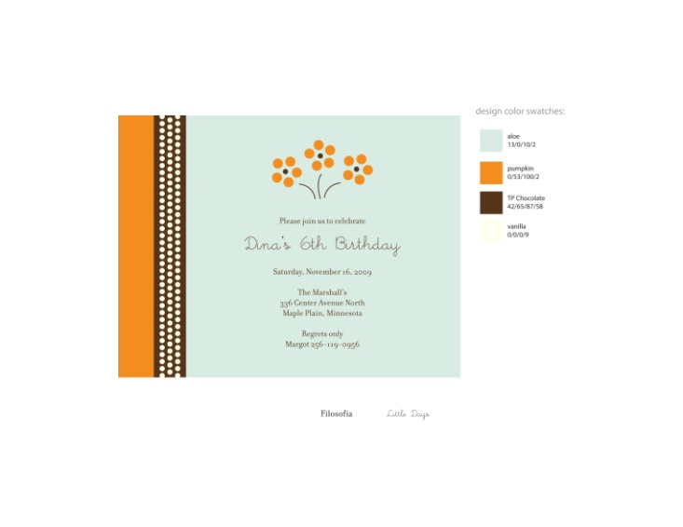 | Pretty Posy  A beautiful bouquet of flowers adorns this sweet birthday invitation. It’s sure to make your little girl feel pretty special.  Keywords: baby, kid, child, invite, cards, greeting, announcement, happy, girl, celebration, fun, stripe, dots
Rocket Ship

Make your little one’s birthday an exciting adventure. Send out our party invitations designed with a rocket ship heading out to the stars.

Keywords: birthday, baby, kid, child, invite, cards, greeting, announcement, happy, girl, boy, celebration, space
Dotted Belt

Ask everyone to come and celebrate your daughter’s birthday with a party invitation that’s stylish and pretty! Our photo invitations are fun and fashionably adorn to let everyone know who the guest of honor will be.

Keywords: birthday, baby, kid, child, invite, cards, greeting, announcement, happy, girl, boy, celebration, frame, picture
Baby Dots

Honor the mother-to-be with a splash of color in our baby shower invitations! The word baby is filled with polka dots and makes our cards so cheerful and fun!

Keywords: invite, mom, guests, friends, family, frame, requests, personalize
Criss-Cross

Our baby shower invitations are delicate and sweet. Perfect for this occasion, perfect for the mom-to-be. Send them as a beautiful request to get guests to come out and celebrate.

Keywords: invite, mom, guests, friends, family, frame, requests, personalize, dots
Sweet Dreams

Our crib mobile adds a nice touch to your baby shower invitations. Sure to bring sweet dreams for the mother-to-be and baby. With an adorable moon, star, heart and teddy bear mobile that makes it charming.

Keywords: invite, mom, guests, friends, family, frame, requests, nursery, baby mobile

Falling Hearts

Our Falling Hearts baby shower invitations will make hearts melt. You’re letting guests know you care with a flutter of raining heartsand sending some love the honoree’s way so that she’s sure to feel the love on her special day!

Keywords: bridal shower, invite, request, friends, family, women, ladies, celebration, party, get together, tiny hearts
Baby Bow

Wrap your party with the details that will make her baby shower unique! Request guests presence with our elegant party invitations. Adorned with a delicate bow and circle border, our cards say fun and class in a very stylish way!

Keywords: baby shower, invite, request, friends, family, women, ladies, celebration, party, get together, ribbon, frame
Hip Chicks

Want to send out the word about your new bundle of joy? Our little birds will send out the word. A big chick and little chick make your announcements soft and sweet.

Keywords: baby, infant, newborn, sister, sibling, birth announcement, card, photo, picture
Big Sister (little sister)

Make her feel proud in her new role as big sis. Send our baby announcements with a photo of your grown up girl and her new little sister.

Keywords: baby, infant, newborn, sister, sibling, daughter, birth announcement, card, photo, picture, dots
Big Brother (little brother)

Make him feel proud in his new role as big brother. Send our baby announcements with a photo of your grown up boy and his new little brother.

Keywords: baby, infant, newborn, sibling, son, birth announcement, card, photo, picture, dots
Big Brother (little sister)

Make him feel proud in his new role as big brother. Send our baby announcements with a photo of your grown up boy and his new little sister.

Keywords: baby, infant, newborn, sister, brother, sibling, daughter, son, birth announcement, card, photo, picture, dots
Big Sister (little brother)

Make her feel proud in his new role as big sister. Send our baby announcements with a photo of your grown up girl and his new little brother.

Keywords: baby, infant, newborn, sister, brother, sibling, daughter, son, birth announcement, card, photo, picture, dots
Cuddly Cubs

Our teddy bear brothers show their brotherly love with an announcement that will get everyone’s attention! Send out our adorable cards to share your excitement with friends and family that your little one is here.

Keywords: cards, baby, infant, news, girl, boy, child, sibling, stripe, heart

Petite Posy

We kept our designs simple with a miniature posy bouquet.! We did this so your baby’s older sibling can announce her debut! Our announcements frame your little one’s precious photo.

Keywords: cards, baby announcement, birth announcements, infant, child, sister, girl, pink, flowers

Baby Monogram

We kept our designs simple with a laurel leaf and monogram. We did this so your baby’s older sibling can announce his debut! Our announcements frame your little one’s precious photo.

Keywords: cards, baby announcement, birth announcements, infant, child,
Leaflet Tendril

Your little girl is precious and sweet. And our birth announcements are the perfect accessory. Send your daughter’s first photo with our pretty monogram cards.

Keywords: baby announcements, cards, infants, notice, friends, family, child, sibling, girl, , daughter, announce, leaf, initial, picture
Dotted Love

Welcome loved ones to a first viewing of your little one! Our photo birth announcements were created just for him. In a flurry of dashing dots, we help introduce your baby in style.

Keywords: baby announcements, cards, infants, notice, friends, family, child, sibling, girl, boy, son, daughter, announce, initial, picture, monogram
Fashion Stripes

He’s so fresh and brand new and with our contemporary cards he’ll be all dressed up too. Your little guy will be handsome and looking sharp with our birth announcements dressed in fashionable stripes.

Keywords: baby announcements, cards, infants, notice, friends, family, child, sibling, boy, son, announce, diagonal stripes, picture
Sweetly Scalloped

Little girls are made up of everything sweet. And our photo birth announcements dressed with scalloped edges and corner dots highlights her sweet self.
Keywords: baby announcements, cards, infants, notice, friends, family, child, sibling, girl, daughter, announce, picture
Joyful Garden

Our garden is fruitful and thriving! A perfect design to nurture your little one’s first photo. Send our cards to your friends and family to announce the arrival of your new bundle of joy!

Keywords: baby announcements, cards, infants, notice, friends, family, child, sibling, girl, boy, son, removed boy, son since this is the girl version daughter, announce, picture, leaves, modern, contemporary
Ornate Monogram

Decorate your little girl’s picture with our monogram birth announcements. Your daughter’s first initial will be on display in an ornate wreath. It will be such a pretty introduction to friends and family.

Keywords: baby announcements, cards, infants, notice, friends, family, child, sibling, girl, daughter, announce, picture, leafy, floral
Budding Blossoms

Your little bud is about to take center stage with our pretty birth announcements. A growing bouquet of budding blossoms makes a sweet design to decorate your daughter’s photo. Send them to alert family and friends of her long-awaited arrival.

Keywords: baby announcements, cards, infants, notice, friends, family, child, sibling, girl, daughter, announce, picture, leafy, floral, flowers, leaves, branches
Candy Dots

Get ready for some sugary, sweet fun! Our party invitations are dressed in darling dots, perfect for your little girl’s birthday. Find a favorite photo and send them out to all her lucky guests.

Keywords: invite, party, bash, kids, children, friends, family, fun, celebration, circles, polka dots, picture
Monogram Band

We leave our birth announcements simple and sweet. With her monogram and plenty of space for her picture to display.

Keywords: baby announcements, cards, infants, notice, friends, family, child, sibling, girl, daughter, announce, band, initials, photo
Floral Whimsy

Send out your birth announcements with a little whimsy! Our cards are decorated with a fun floral design. They add a bit of contemporary style to your daughter’s adorable photos.

Keywords: baby announcements, cards, infants, notice, friends, family, child, sibling, girl, daughter, announce, picture, leaves, vine
Baby Branch

Announce the birth of your little one with our delightful birth announcements! Tiny dots frame your child’s photo and darling trees make our cards so charming.

Keywords: baby announcements, cards, infants, notice, friends, family, child, boy, girl, son, daughter announce, picture, leaves, branches
Apple Crisp

Take a bite of our refreshing cards! An apple a day may keep the doctor away, but it sure won’t keep friends and family far! Send them our adorable birth announcements freshly designed with a juicy apple.

Keywords: baby announcements, cards, infants, notice, friends, family, child, sibling, girl, boy, son, daughter, announce, dots, border, frame, fruit
Little Ladybug

Our spring birth announcements are so adorably sweet. A little ladybug hangs out on a grassy leaf waiting to deliver good luck and happy wishes to your friends and family. Send them with your daughter’s first photo to get everyone tickled pink.

Keywords: baby announcements, cards, infants, notice, friends, family, child, sibling, girl, boy, son, daughter, announce, grass, sky, picture
Baby Stamp

Frame your little one’s photo as a pretty postage stamp! Send our precious birth announcements and you’ll make hearts melt. Our cards with your baby’s photo will be simply adorable.

Keywords: baby announcements, cards, infants, notice, friends, family, child, boy, son, announce, picture, square, vertical line, frame
Nest Egg

A precious nest filled with tiny eggs makes our birth announcements so sweet and charming. Send them with your newborn’s photo to bring friends and family a gift they will cherish forever.

Keywords: baby announcements, cards, infants, notice, friends, family, child, sibling, girl, boy, son, daughter, announce, picture, birds nest
Twin Hearts

Our twin birth announcements were made especially for you and your pretty pair of sisters. With two places for two baby girl photos, our cards are delightfully sweet and ready for you to send to loved ones.
Keywords: baby announcements, cards, infants, notice, friends, family, child, sibling, girl, daughter, announce, twin, hearts, picture
Butterfly Garden

Spring is in the air with our pretty party invitations! Our cards are butterfly filled perfect for your little girl. Send them out to get everyone ready to celebrate her special day!

Keywords: invite, birthday, party, girl, daughter, child, kids, baby, friends, family, get together, fun, print
Dandelion Dance: Boy

Welcome your new baby to your loved ones. We dress up our birth announcements with a seasonal flurry of dandelions. Together with your son’s photo, our cards will get your friends and family saying, “Oh boy!”

Keywords: baby announcements, cards, infants, notice, friends, family, child, sibling, boy, son, announce, flowers, leaves, picture
Dandelion Dance: Girl

Welcome your new baby to your loved ones. We dress up our birth announcements with a seasonal flurry of dandelions. Together with your daughter’s photo, our cards will deliver happiness and joy to friends and family.

Keywords: baby announcements, cards, infants, notice, child, sibling, girl, daughter announce, flowers, leaves, picture
Baby Fern: Boy

Ferns make everything fresh and tropicaland a fern motif makes our birthday party invitations fun and ready for your picking! Send them out to get friends and family to help celebrate your son’s birthday.

Keywords: invite, birthday, party, boy, son, child, kids, baby, friends, family, get together, fun, leaf, nature
Baby Fern: Girl

Ferns make everything fresh and tropicaland a fern motif makes our birthday party invitations fun and ready for your picking! Send them out to get friends and family to help celebrate your daughter’s birthday.
Keywords: invite, birthday, party, girl, daughter, child, kids, baby, friends, family, get together, fun, leaf, nature
Darling Duo: Twin Boys

Show off your twin boys with our fun photo birth announcements decorated with their pictures and initials. With a baby boy on each side, this adorable brother duo will deliver double the joy to your friends and family.

Keywords: baby announcements, cards, infants, notice, friends, family, child, sibling, boy, son, twin, brothers, announce, initial, monogram
Darling Duo: Twin Girls

Show off your twin girls with our fun photo birth announcements decorated with their pictures and initials. With a baby girl on each side, this adorable sister duo will deliver double the joy to your friends and family.

Keywords: baby announcements, cards, infants, notice, friends, family, child, sibling, girl, daughter, twin, sisters, announce, initial, monogram
Darling Duo: TwinBoy and Girl

Show off your twins with our fun photo birth announcements decorated with their pictures and initials. With a twin on each side, this adorable duo will deliver double the joy to your friends and family.

Keywords: baby announcements, cards, infants, notice, friends, family, child, sibling, boy, son, girl, daughter, twin, brother, sister, announce, initial, monogram
Darling Duo: Twin Girl and Boy

Show off your twins with our fun photo birth announcements decorated with their pictures and initials. With a twin on each side, this adorable duo will deliver double the joy to your friends and family.

Keywords: baby announcements, cards, infants, notice, friends, family, child, sibling, boy, son, girl, daughter, twin, brother, sister, announce, initial, monogram
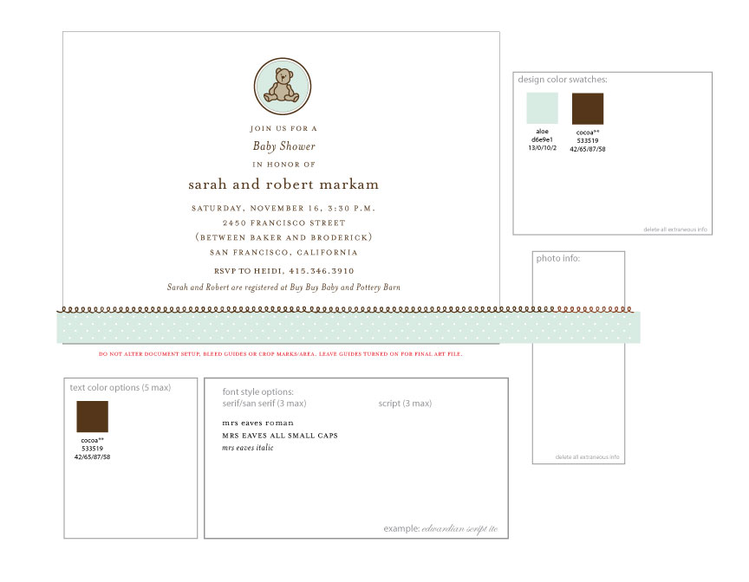 | There will be a girl and neutral version of this design as well.  Bear Love Baby Shower Invitations  A little teddy bear makes our shower invitations so sweet and cuddly. A perfect way to welcome friends and family.  Keywords: baby shower, invite, friends, family, pregnancy, mother, teddy bear
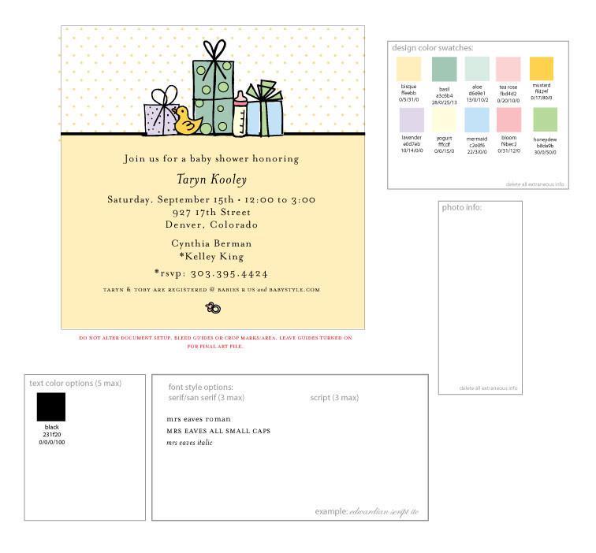 | There will be a boy and girl version of this as well.  Precious Gift  Honor the mother-to-be with our Precious Gift baby shower invitations. With a pretty drawing of shower gifts, our cards will bring her everything she needs. Send them to help guests get ready to celebrate!  Keywords: baby shower, invite, friends, family, pregnancy, mother, duck, bottle, presents, gifts
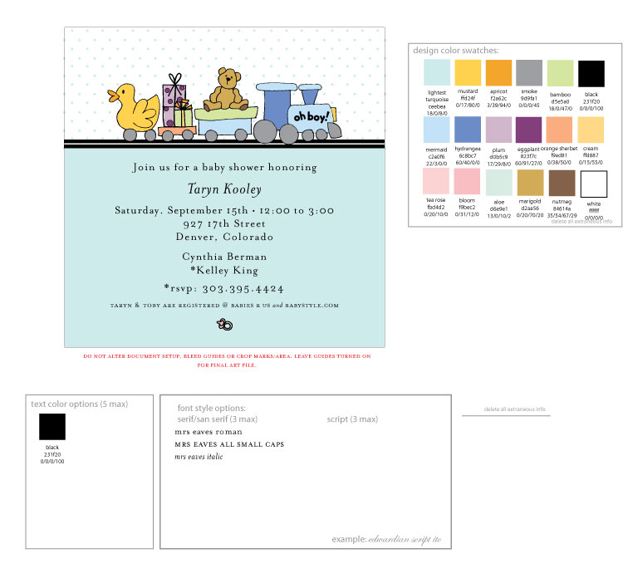 | There will be a girl and neutral version of this.  Birthday Train  Hop on the baby train! Our baby shower invitations are adorable and cute. Just the thing you were searching for to help celebrate the mom-to-be!  Keywords: baby shower, invite, friends, family, pregnancy, mother, duck, presents, teddy bear, train
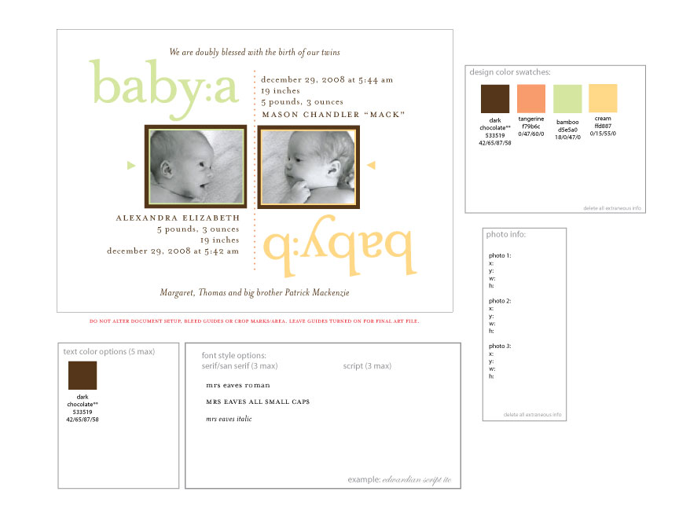 | Baby Letters  Doubly blessed? Then send our perfectly suited baby a and baby b photo birth announcements. They make a delightful introduction to friends and family about your two lovable bundles of joy!  Keywords: baby announcement, announce, notice, friends, family, picture
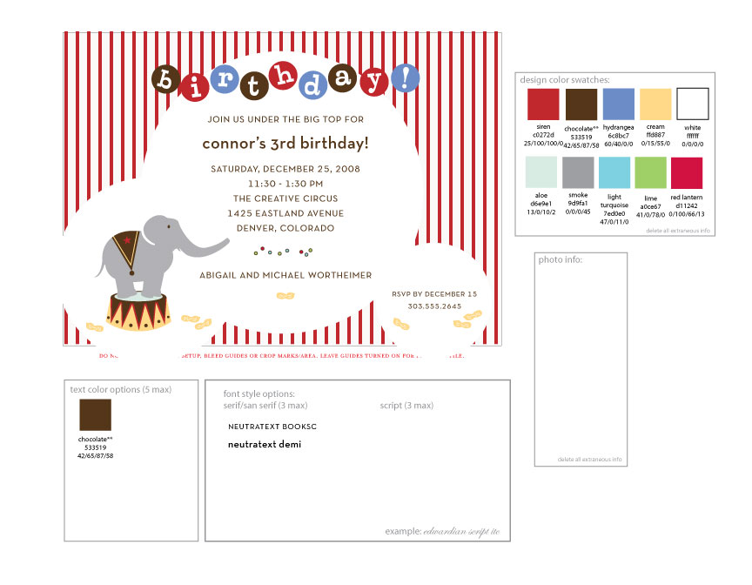 | Elephant Circus  Bring the circus to your party invitations for elephant-sized fun! Send out our birthday invitations to get all your guests filled with glee. Our cards are decorated with stripes and an elephant for a festive circus theme.  Keywords: invite, party, child, kids announce, request, guests, friends, family, elephant, peanuts, circus
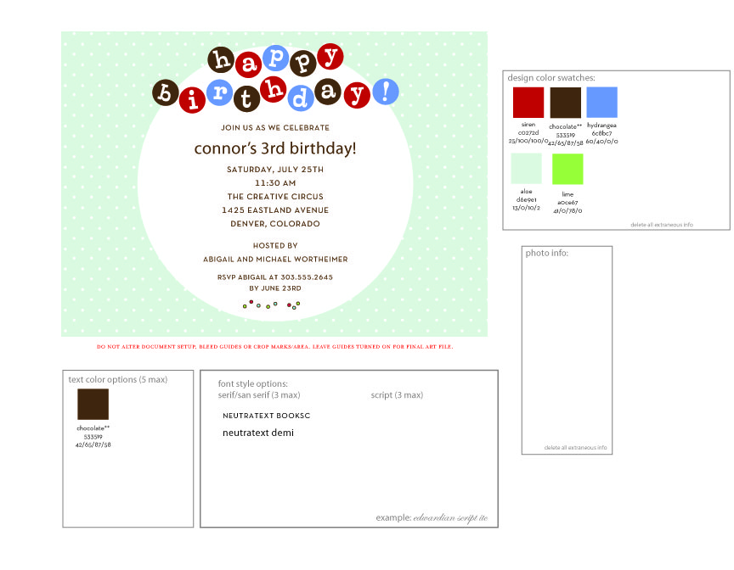 | There will be a girl version of this.  Birthday Dots  Happy Birthday to your little one! In their honor, we have the perfect party invitations for you. Send our festive cards filled with dots for a playful invite to their special day!  Keywords: invite, party, child, kids announce, request, guests, friends, family, dots, banner
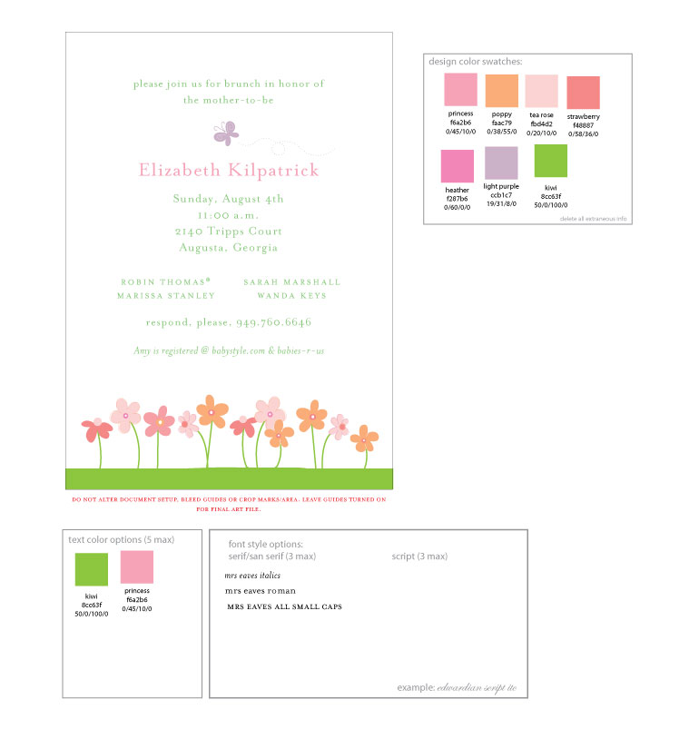 | Spring Garden Baby Shower  Everything is springing up nicely with our Spring Garden baby shower invitations! Send them to invite loved ones to celebrate the mommy-to-be.  Keywords: baby shower, invite, friends, family, flowers, butterfly, nature, pregnancy, mother
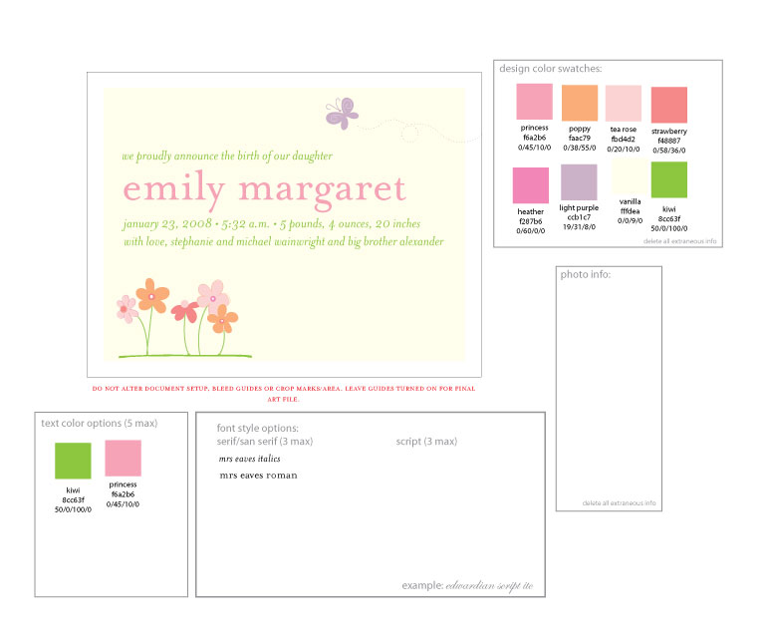 | Spring Garden Birth Announcement  Everything is springing up nicely with our Spring Garden birth announcements! Send them to introduce loved ones to your new little bundle.  Keywords: baby announcement, announce, notice, friends, family, flowers, butterfly, nature, girl, daughter, newborn, infant,
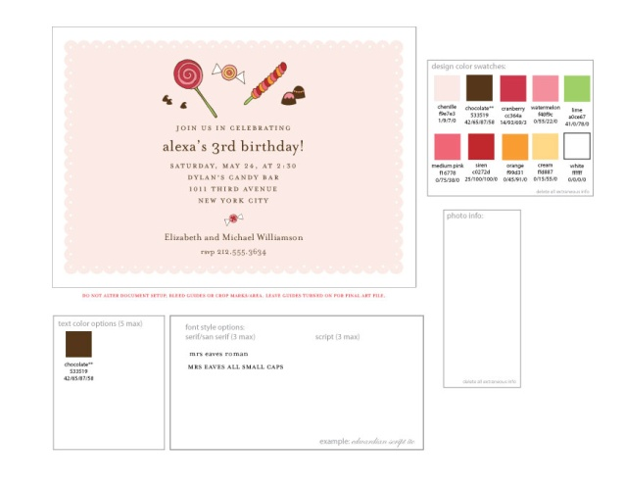 | PRIORITY  There’s a boy version of this as well.  Sweet Treats  Get them ready for a sweet treat! Send out your child’s birthday invitations with a parade of mouthwatering sweets. From lollipops to peppermint drops, all will be eager to attend your child’s birthday party!  Keywords: invite, party, child, kids candy, announce, request, guests, friends, family
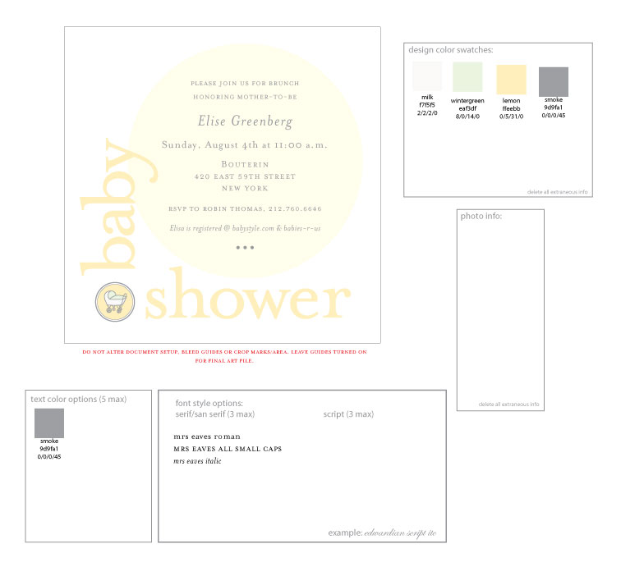 | There will be a girl and boy version of this.  Baby Bassinet  Honor the mother-to-be with our adorable shower invitations! A tiny bassinet motif makes this invitation particularly sweet. Send them out for a simple way to make her feel special.  Keywords: baby announcement, announce, notice, friends, family, newborn, infant, circle, shower
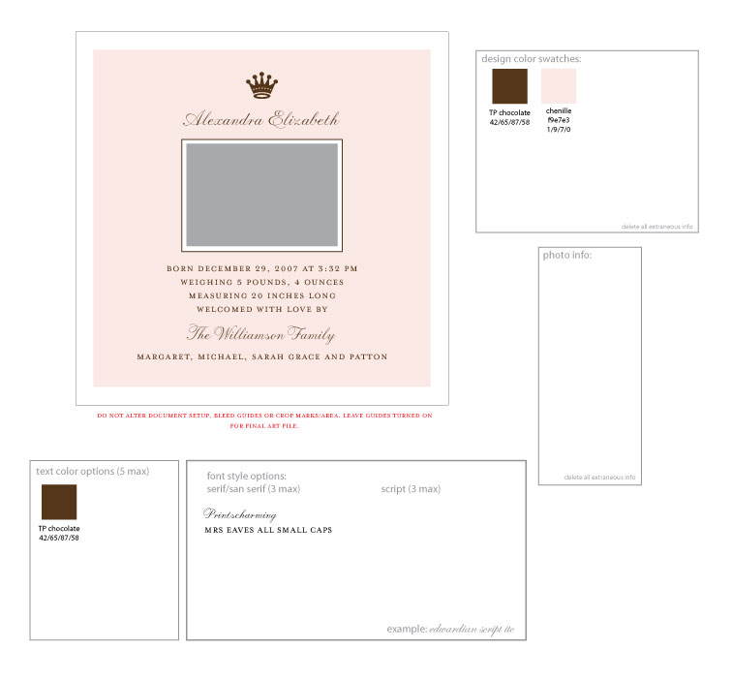 | There will be a boy version.  Royal Baby  Send friends and family a birth announcement fit for a King and Queen! With a photo of your little one and a royal crown to suit, our cards are a majestic display of your little, precious crown jewels.  Keywords: baby announcement, announce, notice, friends, family, circle, peas, pea pod, baby, newborn, infant
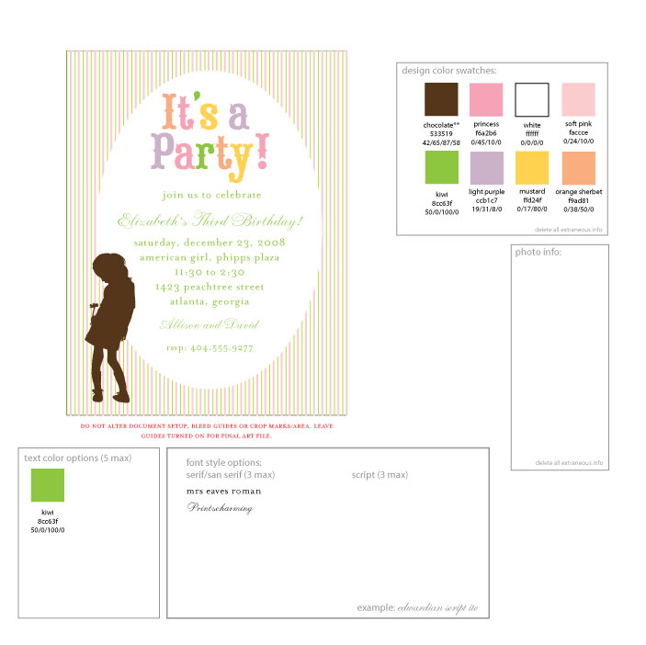 | PRIORITY  Party Girl  This little girl may be a wallflower but she does want to party! Celebrate your daughter’s birthday with our sweet invitations. With a silhouette of a girl holding a flower and decorated with colorful stripes, our cards are sure to grab the attention of all your guests!  Keywords: birthday, invite, loved ones, party, get together, child, kids, stripes, girl, daughter, flower
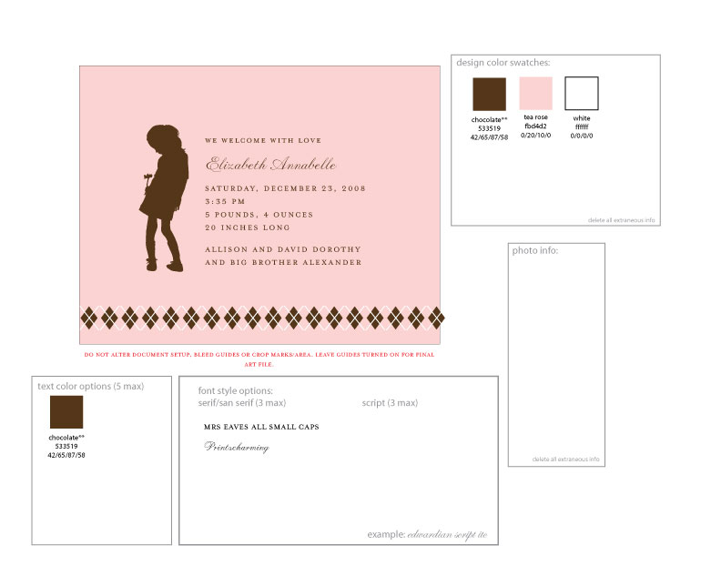 | PRIORITY  There may be a boy version of this.  Baby Argyle  Welcome your newborn with our fashionable birth announcements! Dressed in modern argyle print and a child’s silhouette, our cards will introduce your little one in style.  Keywords: baby announcement, announce, notice, friends, family, newborn, infant, flower, argyle
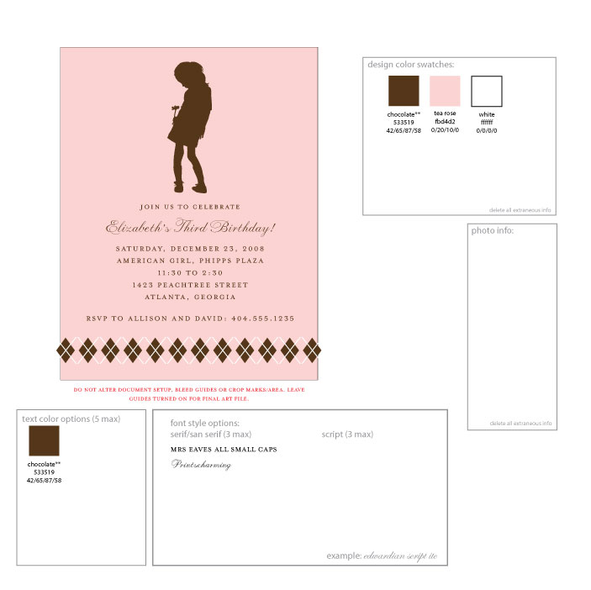 | PRIORITY  There may be a boy version of this.  Preppy Argyle  Celebrate your child’s birthday with our fashionable party invitations! Dressed in modern argyle print and a silhouette of the birthday child, our cards will gather everyone for a stylishly good time!  Keywords: birthday, invite, loved ones, party, get together, child, kids
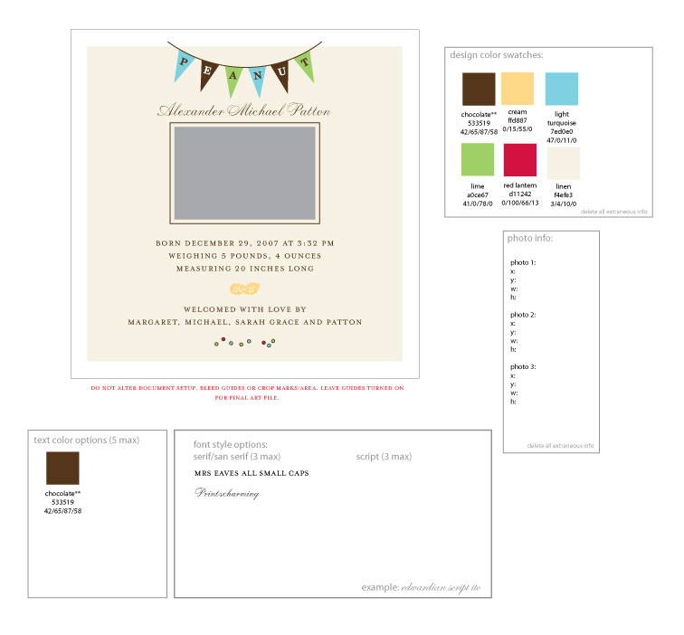 | Little Peanut  Your little peanut is so cute! We have a perfect birth announcement that is adorable too! Send them our cards with their picture decorated with a banner and a tiny peanut motif.  Keywords: baby announcement, announce, notice, friends, family, newborn, infant, peanut, pennant, photo
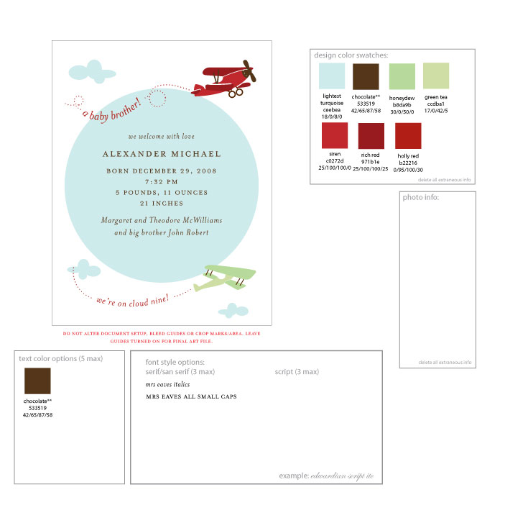 | Toy Plane  What a welcome! Let everyone you know your little one is here. Our birth announcements with toy planes will set your loved one’s hearts soaring high with love and excitement for the new baby!  Keywords: baby announcement, announce, notice, friends, family, newborn, infant, clouds, planes
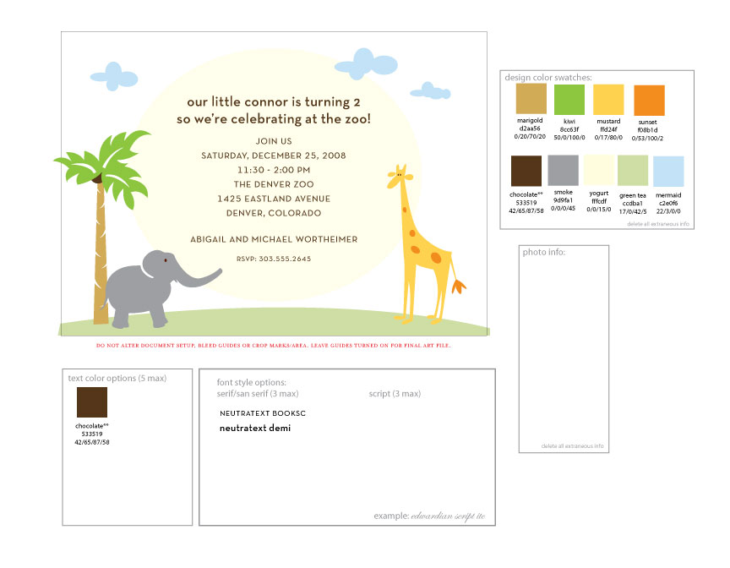 | This is a b-day party invite of this design.  Animal Family Birthday Invitations  Your son’s birthday is coming up and we have the perfect birthday invitations for you! Send friends and family our cards decorated with an animal theme.  Keywords: birthday, invite, loved ones, party, get together, child, son, kids, zoo, animals, elephant, giraffe
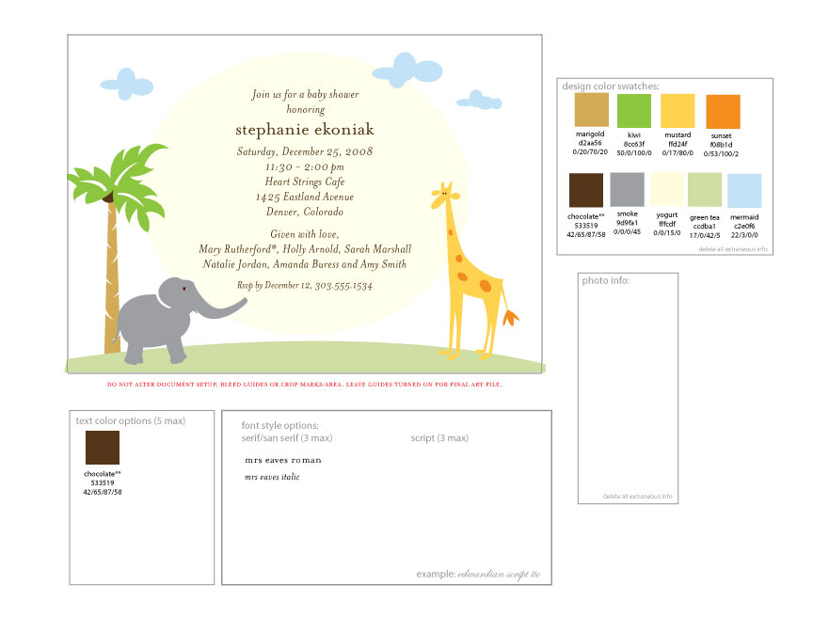 | This is a baby shower invite of this design.  Animal Family Baby Shower Invitations  Welcome the mom-to-be with a little animal fun! Our baby shower invitations features an elephant and giraffe. What a fun way to get guests to celebrate the arrival of the new baby.  Keywords: baby announcement, announce, notice, friends, family, newborn, infant, animal, tree, clouds, picture
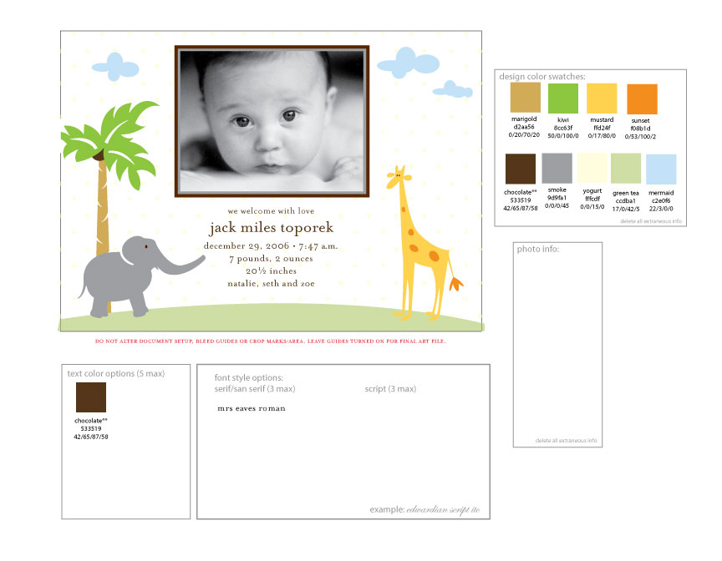 | Animal Family  Welcome your little one with some animal fun! Our photo birth announcement features an elephant and giraffe too. What a fun way to show your little animal family too.  Keywords: baby announcement, announce, notice, friends, family, newborn, infant, animal, tree, clouds, picture
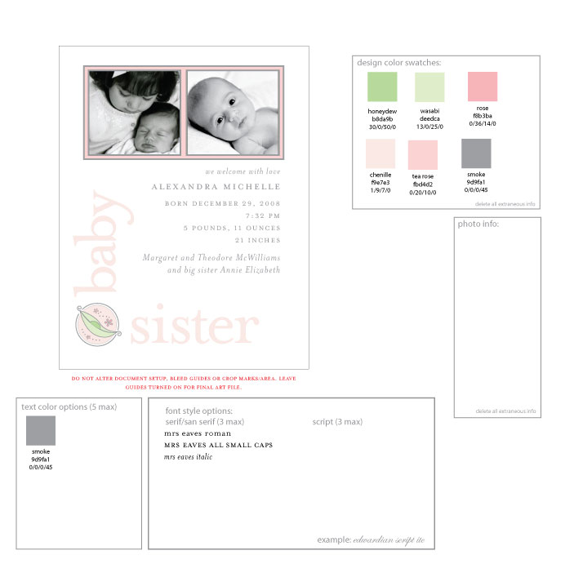 | Not sure if this will end up having 2 photos, I think I asked for one large photo.  Baby Pea Birth Announcements  She’s so tiny and sweet! Send a picture of your daughter and her new baby sister with our cards adorn with a sweet pea pod.  Keywords: baby announcement, announce, notice, friends, family, circle, peas, pea pod, daughter, girl, baby, newborn, infant
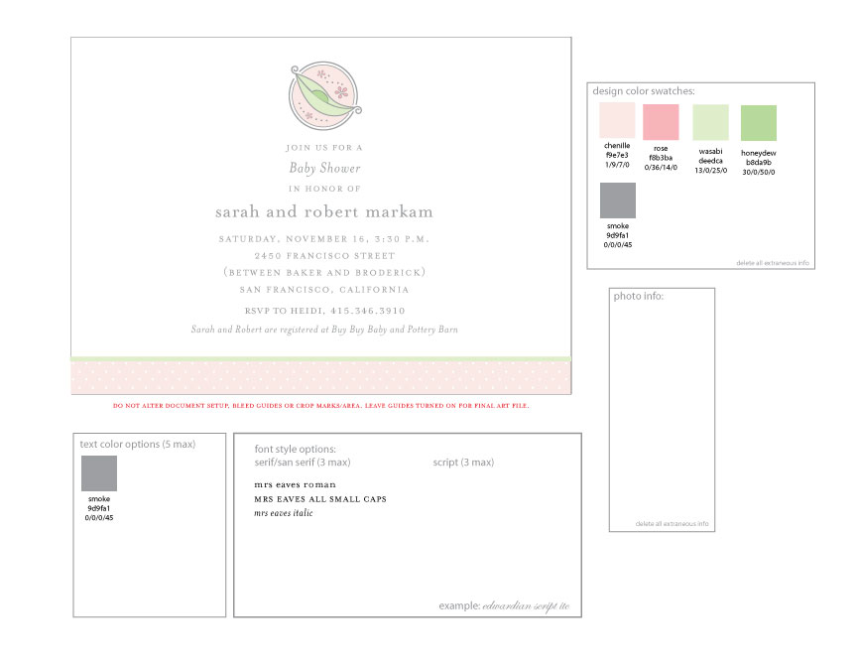 | Baby Pea Shower Invitations  Honor the mom-to-be with our Baby Pea shower invitations! A cute pea pod adorns this charming card. Send them to ask everyone to help celebrate.  Keywords: baby shower, party, kids, friends, family, pregnancy, mom, mother-to-be, circle, pea
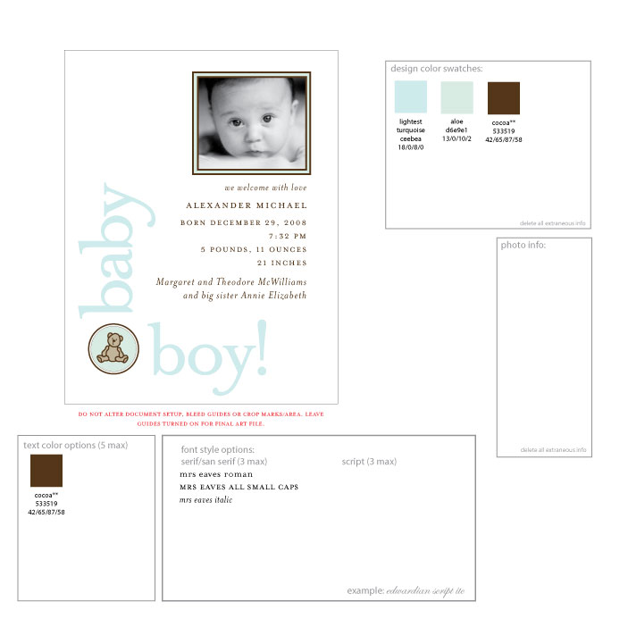 | Bear Love  A little teddy bear makes our birth announcements so sweet and cuddly. A perfect card to welcome your sweetie. Send them with your baby’s first photo for a sweet introduction to friends and family.  Keywords: baby announcement, announce, notice, friends, family, teddy bear, picture, newborn, infant
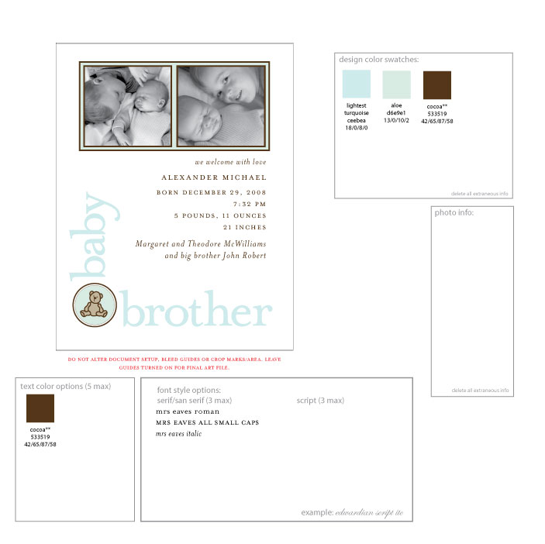 | Brotherly Love  Look who is growing up! Let your older child feel like the big boy he is by sending these birth announcements. Both children can be featured together with an adorable teddy bear.  Keywords: baby announcement, announce, notice, friends, family, teddy bear, picture, newborn, infant
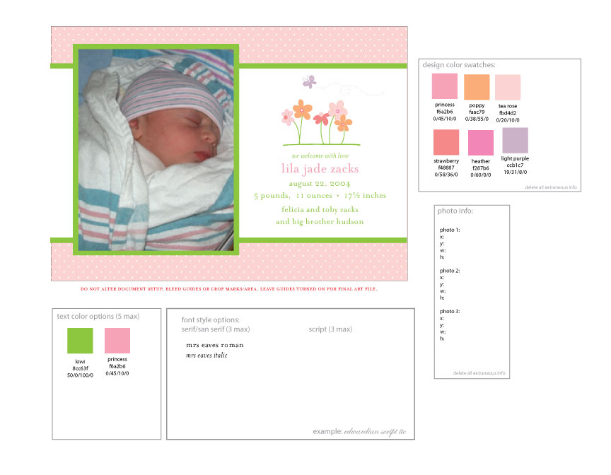 | Spring Garden Photo Birth Announcement  Everything is springing up nicely with our Spring Garden birth announcements! Send them to introduce loved ones to your new little bundle. Her picture will fit so nicely in with our spring theme.  Keywords: baby announcement, announce, notice, friends, family, flowers, butterfly, nature, girl, daughter, newborn, infant, picture
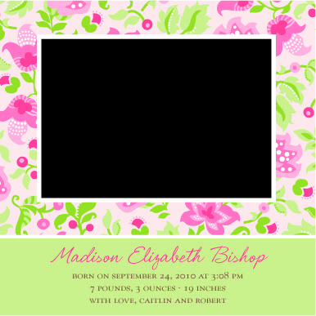 | Easter Floral  Send sweet thoughts their way with our photo birth announcements that reminds us of everything spring and floral! Our cards make it easy to introduce your little one to your friends and family in style.  Keywords: baby announcement, announce, notice, friends, family, flowers, leaves, wallpaper, newborn, infant
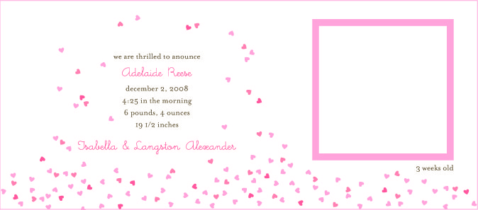 | Raining Hearts  You’ll need an umbrella because it’s raining hearts and our birth announcements show it! Send everyone a photo of your daughter with this pretty card flooded with tiny hearts.  Keywords: baby announcement, announce, notice, friends, family, hearts, picture, newborn, infant
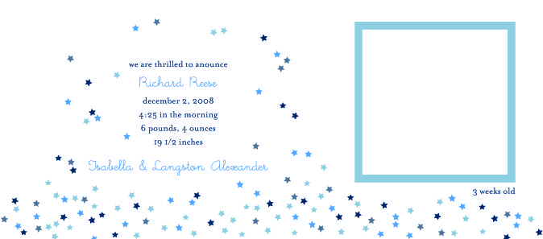 | Star Shower  You’ll show them your shining star with our birth announcements filled with tiny stars! Send everyone a photo of your son with this star-filled card.  Keywords: baby announcement, announce, notice, friends, family, stars, picture, newborn, infant

