

Banks Try, Try Again to Profitably Woo Mass Affluent
Rob Garver
OCT 4, 2011 5:04pm EDT
When HSBC CEO Stuart Gulliver announced earlier this year that the company would abandon its push to bring six million account holders into its Premier banking service, it appeared to confirm what some observers of the banking industry have long believed: trying to provide specialized financial services to the mass affluent through bank branches is a mug's game.
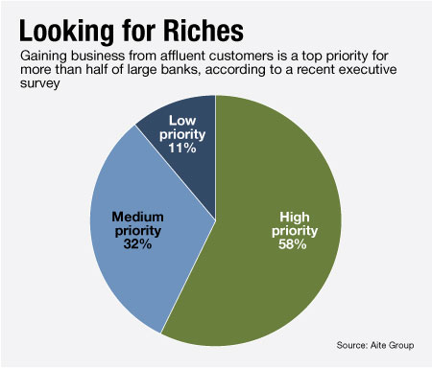
HSBC officials cited the high costs of the program, which had been scheduled for aggressive expansion through 2012, as a reason for shutting down the push for new customers two years and more than 1.5 million accounts shy of its original goal.
But despite stumbling in its expansion, HSBC is not giving up on Premier entirely. And other banks, including Bank of America Corp., are taking aim at the same group of "mass affluent" customers, who generally have between $50,000 and $1 million in investable assets.
Those banks have a tricky path to navigate on the way to a successful mass affluent program, according to Sophie Schmitt, a senior analyst in the wealth management division of Aite Group in Boston.
Most banks are interested in cross-selling investments to their mass affluent customers — but their success rate is about 36% at best, and generally much worse, according to an Aite survey early this year.
Schmitt cites a frequent disconnect between the front-line financial advisors, who have an incentive to enroll as many clients as possible, and bank management, which sees real benefits in restricting services to higher-end depositors.
"The financial advisors will take anyone because of that possibility of the client hitting the jackpot and potentially making more money in the future," said Schmitt.
The result of this conflict is rarely pretty. One of the signature problems of the HSBC program was its failure to match a client's true amount of investable assets to the bank's target amount. Like many banks that have attempted to launch mass affluent programs, HSBC initially allowed a customer's mortgage to count toward his or her total investable assets — creating a subset of clients who had all the expectations of new Premier service members, but could not necessarily generate any of the profits the banks needed to sustain the program.
"If you look under the hood you see a lot of clients who shouldn't even be there — they don't want the investment services, they want the banking services," Schmitt says.
But there are institutions that have managed to establish successful mass affluent programs. Analysts cite Key Bank, Huntington Bancshares Inc. and PNC Financial Services Group Inc. as examples of banks that have succeeded where HSBC and others fell short.
Ken Kehrer, of the research and consulting firm Kehrer-LIMRA, says that banks can actually do very well serving the mass affluent as long as they keep the business in perspective.
"Banks have been very successful at this, much more successful than regional brokerage firms of the same size," says Kehrer. "The typical regional brokerage firm typically has a profit margin of less than 10%. Last year the average profit margin in a bank brokerage was 27% and there are lots in the 30 to 40% range."
The problem is that while banks can offer services to the mass affluent successfully, they can rarely generate enough profits to justify investing in those services.
"Even though it is very profitable, they don't make enough profit," says Kehrer. "These programs typically make up only 2% to 3% of the banking enterprise's bottom line. In a large banking enterprise that is considered a marginal business, so they have tended to under-invest in that business despite its high profit margin."
Now other, larger banks are trying to win over enough of the mass affluent market to make it worth their while. Bank of America, which already has some 8 million account holders who qualify as mass affluent investors, is one of the latest companies to try to capitalize on that customer base. The largest U.S. bank by assets has developed its Preferred Customer program to serve those existing, wealthy customers.
"This is a largely underserved segment of the population," says Dean Athanasia, mass affluent and small business segment executive for B of A's consumer and small business bank. "Online brokers cover a piece of it, banks cover a piece of it, people have dipped in and dipped out. Because we are uniquely made up we can provide both sides and we have the infrastructure."
He says that one of B of A's largest advantages is its ownership of Merrill Lynch, and the Merrill Edge discount brokerage platform it launched last year. While other banks have struggled with losing smaller investors to the likes of Charles Schwab Corp. and E-Trades of the world, B of A executives say it is possible to allow self-directed investing while still providing financial consultants for those clients who need them.
B of A set a program target of 10% growth in customer investments per year, and is hoping that new employees will help it reach that goal. In June the bank said it would be adding 500 financial advisors, nearly doubling the current amount, by the end of 2011.
A Bank of America spokesperson said last month that while the bank has recently announced significant job cuts and fired its top wealth management and consumer banking executives, the bank "is going to continue to add roles in areas where we have identified growth opportunities, such as the Merrill Edge program."

